INTRODUCTION
Use of FLAC3D for mining induced seismicity prediction
V.V. Nazimko
DonNTU., Donetsk, Ukraine
K.V. Babenko
UkrNIMI, Donetsk, Ukraine

ABSTRACT: This paper demonstrates the possibility of mining induced seismicity (MIS) prediction with FLAC3D that explicitly involves the time. The higher the rate of deposit extraction is, the more dynamic event occurrence is possible in vicinity of a moving face as a result of accumulation of potential energy due to rock mass deformation. Increase of the rate of longwall face advance shifts the state of surrounding rocks from equilibrium. The rate of advance has been calibrated in a numerical model using experimental data from extensometers displacement monitoring. Seismic factor calculation based on an idea that increase equivalent stress–its-derivate production builds up potential energy of rock mass deformation and raises probability of dynamic failure if the rate of the energy dissipation is low. Comparison of simulated seismic events distribution with experimental data demonstrated good agreement.
Proceedings of the 2nd International FLAC /DEM Symposium on Numerical Modeling – 2011,
February, 14-16, 2011, Australia
Recent publications indicate growing concern for MIS caused by increase of deposits extraction rate (Chavan et al. 1995, Van Aswegen 2003, Dubinski et al. 2005). For instance, longwall faces progress with speed from 300 to 500 m per month provides accumulation of potential energy of rock mass deformation. The higher the rate of advance is, the more chance of dynamic event may occur in the vicinity of the moving face. Dynamic failure of rock mass exposes miners to risk, causes severe damages for mining equipment and financial lost.
FLAC3D explicitly uses inertial terms as a numerical mean to reach equilibrium state. However, increase of the rate of a face advance moves away the surrounding rocks from equilibrium. Therefore, the rate of a face advance can be calibrated by selection of a proper number of cycles during solving current state of a model. It does mean that finish of cycling should not be controlled by convergence criterion but with force unbalance reduction to a level which corresponds to an actual unbalance occurring under specific rate of a face advance. This approach has been tested on a problem of MIS simulation during coal face retreating.

CALIBRATION OF THE MODEL
FLAC3D (Itasca 2008) code has been used to simulate MIS that was induced by moving longwall face. The face of 240 m long retreated by step increments. The step was 40 m id est. six times less than the length of the face. Every step cycled a number of iterations that provided such a rate of model continuum deformation which corresponded to the actual rate of rock mass strain. The actual rate has been adopted from data collected during strata movement monitoring at Zasiadko coal mine.
Immediate roof of the coal seam, 1.45 m thick, has been presented with argillite having uniaxial compression strength of 40 MPa and whose thickness varied from 8 m to 12 m. A competent thick sandstone presents main roof. This rock layer is usually the main source of dynamic failures that induces MIS. Fragment of mine map is shown in Figure 1. A single isolated coal longwall face retreated East panel in the direction which indicated by arrow. The face kept the rate of advance in range from 5 to 7 m per day. MIS has been monitored during retreating East coal face.
Eighteenth panel was employed to collect difference of rock mass deformation due to variation of the face advance rate. Rate of the 18th face progress deviated from 2 to 7 m per day. This face was idle during several days that provided a wide range of the advance rate. Strata deformation was monitored in a vertical hole that had been drilled in the head entry. The hole position is indicated by cross and numbered by 1 in Figure 1. The hole has been instrumented by five extensometers that were installed to the depth of 7 m. The deeper extensometers are #1 and #2. Distance between these extensometers was 2 m. The experimental entry has been maintained behind the longwall face to provide direct ventilation of the face for safety reasons. This facilitated in collection the sufficient data for assessment of impact of face rate retreat.
Figure 1. Fragment of mine map.

Figure 2 shows extensometers displacement as the longwall face retreated. The most intensive ground movement occurred in vicinity of the entry. Figure 2A indicates movement of extensometers relatively the hole mouth as time elapsed. Figure 2B provides dependence of hole intervals dilation on distance between the experimental hole and the 18th longwall face. The empty arrow indicates position of the face and direction of mining. Vertical arrow in the Figure 2B indicates the period of 18th face idling. Both plots demonstrate that extensometers #1 and #2 have been installed out of a zone where the entry impacts ground movement essentially. That is why dilation of the hole interval between these extensometers has been used for calibration because it is the most stable and reflects net deformation of rock mass.

Figure 2. Ground movement registered in situ with extensometers.

Comparison of plots in Figures 2A and 2B demonstrates that space gradient of deformation is more sensitive.
Another advantage of strain gradient is absence of the problem of time scale coordination in the model and in situ. This problem involves a great number of physical and geologic parameters and may not be solved without a set of assumptions that increase uncertainty of final results. That is why strain gradient has been chosen as a parameter for calibration the rate of face advance in the FLAC3D model.
Monitoring of MIS in situ proved that if rate of longwall advance at Zasiadko coal mine does not succeed 2 m per day, energy of registered MIS may be neglected. This critical rate of advance v₀ has been adopted as initial one used for calibration process. Rock mass strain gradient was proportional to ratio v/v₀. To calibrate the FLAC3D model, number of cycles should be found which satisfies correspondent proportion for ratio of strain gradients. At first stage, the problem has been solved using a number of cycles that provides recommended by (Itasca 2008) convergence 10⁻⁵. Then relevant number of cycles has been found by trial-and-error method for the rate of advance that used during East panel extraction.

DEVELOPMENT OF CRITERION FOR MIS CALCULATION
Dynamic destruction of rock mass has no theoretical solution so far. Constitutive model of dynamic failure should take into account both traditional parameters which are used for description of nonlinear behavior of rock mass and additional factors such as rate of loading and rate of relaxation. As a basis, we used empirical constitutive model proposed by (Bialek et al. 2004). They found good agreement between surface deformation index I and seismic energy that has been induced by longwall movement. Index I was calculated as a product of subsidence to its derivative. From physical point of view, such an empirical dependence describes a rock mass dynamic failure properly because the more ground deformation and its time derivative the more probable dynamic failure.
Polish investigators used surface subsidence because it is easy be measured in situ. However process of rock mass failure usually has been described by means of equivalent stress. In addition, dynamic failure has a less chance if rate of stress relaxation is large. That is why we propose to use equivalent stress in place of subsidence and to account the rate of relaxation. Finally, we use such a formula to calculate MIS:

$I=\frac{σ_{e}{{dσ}_{e}}/{\text{dt}}}{{dε}/{\text{dt}}}$ (1)
where σ_{e} = equivalent stress, ε = relaxation strain, t = time.
Dimension of I can be presented as (J/m³)² that means square of specific energy. Parameter έ=dε/dt stands for a rate of potential energy dissipation. Volumetric strain rate that FLAC3D calculates substitutes έ.
Equivalent stress was calculated according formula (Shashenko et al. 2003):

$σ_{e}=\frac{(1−ψ)(σ_{1}+σ_{2})+\sqrt{(1−ψ)^{2}\left((σ_{1}+σ_{2})^{2}+4ψ(σ_{1}−σ_{2})^{2}\right)}}{2ψ}$ (2)
where σ_{i} = principal components of the stress, ψ = σ_{t} / σ_{c} where σ_{t} and σ_{c} denote tension and compression limits of rock mass strength respectively.
Constitutive law that has been described by equations (1) and (2) is empirical and has no strict theoretical basis. However it properly reflects the main geomechanic behavior of rock mass under dynamic loading. This law simplifies algorithm of MIS calculation and saves efforts owing utilization of existent tools and advantages that has been developed in FLAC3D so far.
Equation (1) uses time increment which is taken not from FLAC environment but from natural prototype. For instance if a longwall face makes distance 30 m during 2 days then dt = 2 days, etc. In the other words, time inclement for derivative approximation in equation (1) corresponds to space increment of face advance or step of face advance.

RESULTS OF NUMERICAL SIMULATION AND THEIR DISCUSSION
A symmetric half of rock mass volume that surrounds the correspondent half of the East longwall face has been chosen as indicated by dotted rectangle in Figure 1. Distance of bottom and lateral boundaries of the model bottom were both assigned to 200 m from the goaf of East panel. That satisfied boundary conditions in vicinity of the longwall where MIS causes real danger for miners. Normal displacements were restricted on all lateral and bottom boundaries of the model. Gravity and specific weight of the rock mass, of 2500 kg/m³ generated ground pressure around the face that has been moved at the depth of 500 m. Rock mass properties are collected in Table 1.

Table 1. Rock mass properties.
_______________________________________________________________________________________________________
Rock type Modules, GPa Friction angle Cohesion Tension Dilation,
Bulk Shear degree MPa limit, MPa degree
_______________________________________________________________________________________________________
Coal 5.0 3.4 18 0.1 0.1 4
Argillite 8.6 6.0 28 20 8.0 5
Sandstone 15.3 10.2 34 25 12.0 8
_______________________________________________________________________________________________________

Figure 3 shows the grid of the model and MIS events distribution. First, elastic model had been assigned and stress equilibrium was reached in the intact model. Then model has been changed to Mohr-Coulomb type and five successive steps were employed to move the face during MIS problem solving.

Figure 3. Distribution of MIS around the face after its advance to 200 m.

Deterioration of rock mass cohesion and mobilization of internal friction were simulated to imitate process of undermined strata caving. Contact of roof and floor has been accounted by shifting null zone to ubiquitous when sum of immediate roof subsidence and heave of immediate floor exceeded thickness of extracted coal seam. This procedure enhanced solution owing accounting of gob compaction effect.
Square of calculated MIS energy was 4.6*10¹⁶ J² that corresponds to experimental results of (Bialek et al. 2004) who registered amount of induced energy of 1.6*10⁸ J. It can be seen in Figure 3, the majority of MIS occur behind start room and in front of moving longwall face, where abutment zone developed. Sum of the MIS behind the start room was greater because abutment zone developed on the same place which did not move. Abutment zone in front of the face moved as the face retreated. Therefore current MIS intensity is less here.
Approximately same MIS activity has been registered over the gob in undermined strata. Figure 4 demonstrates actual MIS distribution for specified positions of the East longwall face. Fragment A in Figure 4 depicted a case when all MIS expressed behind the start room, whereas fragment B illustrates situation when MIS occurred both in front of the moving face and behind it in the zone of active subsidence.

Figure 4. MIS distributions monitored at Zasiadko coal mine.

Histograms of actual and calculated energy of MIS are depicted in Figure 5. Both histograms can be described by exponential distribution. The most frequent are low energetic seismic events whereas powerful dynamic failures of rock mass occur rarely. Histograms of actual data and calculated energy demonstrate no essential difference according χ-square test. Therefore algorithm developed may be used for prediction mining induced seismicity during longwall extraction.
Final confirmation of this algorithm has been made on the next assumption. We hoped that when the model body is big and face step advance is relatively small and ratio of null zones volume to total volume of the model is negligible, then deviation of stress path in the model from actual path should be in reasonable tolerance. We compared numerical results with experimental measurements of ground pressure dynamics in the gob during longwall face movement (Zborshtchick et al.1991). Longwall panel extracted coal seam at the depth of 550 m.

Figure 5. MIS energy histograms.

Length of the face was 240 m. Roof has been controlled by partial packwall stowing. Two lines of pressure cells were installed along the waste line. As the longwall face retreated, the cells buried under caved rock and built up the ground pressure in the gob.
Gob pressure variation in the model is in good agreement with pressure cell experimental readings (Figure 6, pressure cells from PC1 to PC4). Final gob pressure in the model is 5,78MPa and experimental pressure built up to 6,94MPa. Discrepancy does not exceeds 20%. Level of gob pressure is several times less than overburden pressure in the model like as in situ. This may be explained by arching effect over the gob of a single panel. The gob pressure builds up in the model more intensively than that in situ. Computer model did not account delamination, divergence and successive convergence of rock layers that occur in the gob behind a moving longwall face. Therefore gob pressure builds up more intensively immediately after roof and floor get in contact.
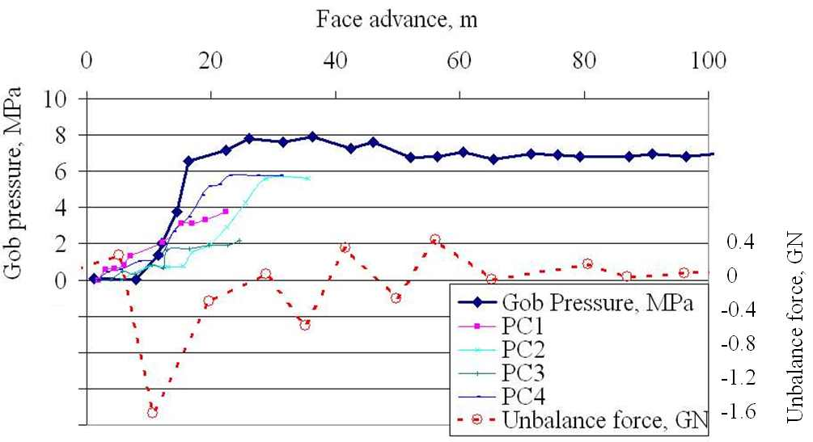
Figure 6. Overlay of gob pressure and unbalance force variation.

Actual roof subsides gradually by portions in a coal mine, namely adjacent rock layers separate and diverge during active stage of ground movement. Reverse convergence of the layers occurs after compaction of delaminated roof that causes gob pressure increase This effect may be simulated by FLAC^{3D} with interface implementation.
Maximum unbalance force occurs immediately after contacting and the force vector oriented along gravity. Unbalance force slightly fluctuates relatively zero level after logwall face withdrawal to the distance of 35 m and more It is natural and corresponds to the nature of undermined rock mass subsidence.
Similarity of dynamics and kinetics of ground movement in vicinity of longwall face approved validity of stopping an early analysis before the model reaches equilibrium.

CONCLUSION
FLAC3D explicitly uses inertial terms as a numerical mean to reach equilibrium state. However force unbalance occurs naturally during intensive deposit extraction. This unbalance is proportional to the rate of longwall movement and may be simulated by selection of proper number of cycles during solving dynamic problem. Rate of longwall advance was calibrated using actual measurement of rock mass strain intensity.
Dynamic failure of rock mass due to intensive longwalling has been simulated using an idea according which the increase of the equivalent stress and of its rate builds up the potential energy of rock mass deformation. Also, raise of probability of dynamic failure occurs provided the rate of the energy dissipation is low.
Comparison of simulated and experimental seismic events distribution in space demonstrated good agreement. Histograms of seismic energy that have been collected on the basis of numeric simulation and actual measurement have no difference according χ-square test. Gob pressure variation in the model is in good agreement with pressure cell experimental readings. Therefore FLAC3D may be used to predict mining induced seismicity during longwall retreat.
Acknowledgement
Authors of this paper acknowledge operators from Zasiadko coal mine for charts of seismic energy distributions.
References
Bialek J., Banka P. & Jaworski A., 2004. Method for description of seismicity basing on changes of rockmass deformation induced by mining. Proc. ISM 12th Int. Congress: 470-475. Fuxin.
Chavan A.S. & Raju N.M. 1995. Prediction of area instability from mining induced seismicity. Rock mechanics Proceedings of the 35th U.S. Symposium: 533-538. Rotterdam: Balkema.
Dubinski J., Lurka A. & Stec K. 2005. Influence of the mining tremor source radiation directivity on the distribution of the seismic interactions with surface. 20th world mining Congress: 889-894. Tehran.
Itasca Consulting Group, Inc. 2008. FLAC3D – Fast Lagrangian Analysis of Continua in 3 Dimensions, Ver. 4.0 User’s Manual. Minneapolis: Itasca.
Shasenko A.N. & Pustovoytenko М.P. 2003. Geomehanics. Kyiv: Novy Druk. (in Russian).
Van Aswegen, G. 2003. Towards best practice for routine seismic hazard assessment in mines. 30th International Conference of Safety in Mines Research Institutes, South African Institute of Mining and Metallurgy: 121-138. Johannesburg.
Zborshtchick M.P., Nazimko V.V., 1991. Roadway maintenance in distressed zone in deep coal mines. Kyiv: Technica. (in Russian).

