OPTIMIZATION OF CONTROL UNIT BASED ON PECULIARITIES OF CPLD

Barkalov A.A., Zelenyova I.Y., Kovalyov S.A., Lavrik A.S. (University of Zielona Gora, DonNTU, Zielona Gora, Donetsk, Poland, Ukraine)

The method of hardware reduction is proposed oriented on compositional microprogram control units and CPLD chips. The method is based on a wide fan-in of PAL macrocells allowing using more than one source of microinstruction address. Such approach permits to minimize the number of PAL macrocells used for transformation of microinstruction address. Conditions for this method application and example of its application are given.

1. Introduction
A control unit is one of the very important parts of any digital system [1]. If a control algorithm to be interpreted is a linear one, then it can be implemented using the model of compositional microprogram control unit (CMCU) [2]. The programmable logic devices with programmable array logic (PAL) macrocells are wide used for implementation of logic circuits of control units [3,4]. The high cost of such devices requires optimization of hardware amount in the circuit of CMCU. One of the ways for this task solution is decrease of the number of conjunctive terms in the sum-of-product (SOP) forms of the functions to be Implemented [5,6]. This article propose some approach for this problem solution based on a wide fan-in of PAL macrocells [3,4]. This approach is targeted on CMCU with address transformer [2] and a control algorithm is represented as graph-scheme of algorithm (GSA) [7].

2. Peculiarities of CMCU with address transformer
Let GSA $Γ$ be represented by sets of vertices B and arcs E. Let $B=\left\{b_{0},b_{E}\right\}∪E_{1}∪E_{2}$, where b₀ is an initial vertex, b_{E} is a final vertex, E₁ is a set of operator vertices, where $\left|E_{1}\right|=\text{M,}$and E₂ is a set of conditional vertices. A vertex $b_{q}∈E_{1}$ contains a microinstruction $Y\left(b_{q}\right)⊆Y$, where $Y=\left\{y_{1},\text{.}\text{.}\text{.},y_{N}\right\}$ is a set of data-path microoperations [7]. Each vertex $b_{q}∈E_{2}$ contains a single element of a set of logical conditions $X=\left\{x_{1},\text{.}\text{.}\text{.},x_{L}\right\}$. Let GSA $Γ$ be a linear GSA, that is a GSA with more than 75% of operator vertices.
Let us form a set of operational linear chains (OLC) $C=\left\{α_{1},\text{.}\text{.}\text{.},α_{G}\right\}$ for GSA $Γ$, where each OLC $α_{g}∈C$ is a sequence of operator vertices and each pair of its adjacent components corresponds to some arc of the GSA. Each OLC $α_{g}∈C$ has only one output $O_{g}$ and arbitrary number of inputs. Formal definitions of OLC, its input and output can be found in [2]. Each vertex $b_{q}∈E_{1}$ corresponds to microinstruction MI_{q} kept in a control memory (CM) of CMCU and it has an address $A\left(b_{q}\right)$. The microinstructions can be addressed using
$$R=\left\lceil {\text{log}}_{2}M\right\rceil$$ | (1)
bits, represented by variables $T_{r}∈T=\left\{T_{1},\text{.}\text{.}\text{.},T_{R}\right\}$. Let OLC $α_{g}∈C$ include $F_{g}$ components and the following condition take place:
$A\left(b_{\text{gi}+1}\right)=A\left(b_{\text{gi}}\right)+1$, | (2)
In (2) $b_{\text{gi}}$ is the i-th component of OLC $α_{g}∈C$, where $i=1,\text{.}\text{.}\text{.},F_{g}−1$.
If outputs $O_{i},O_{j}$ are connected with an input of the same vertex, then OLC $α_{i},α_{j}∈C$ are pseudoequivalent OLC (POLC) [2]. Let us construct the partition $Π_{C}=\left\{B_{1},\text{.}\text{.}\text{.},B_{I}\right\}$, of the set $C_{1}⊆C$ on the classes of POLC. Let us point out that $α_{g}∈C_{1}$ if $\left\langle O_{g},B_{E}\right\rangle ∉E$. Let us encode the classes $B_{i}∈Π_{C}$ by binary codes $K\left(B_{i}\right)$ with
$$R_{1}=\left\lceil {\text{log}}_{2}I\right\rceil$$ | (3)
bits and use the variables $τ_{r}∈τ=\left\{τ_{1},\text{.}\text{.}\text{.},τ_{R_{1}}\right\}$ for the encoding. In this case a GSA $Γ$ can be interpreted using the model of CMCU U₁ with address transformer (Fig. 1).

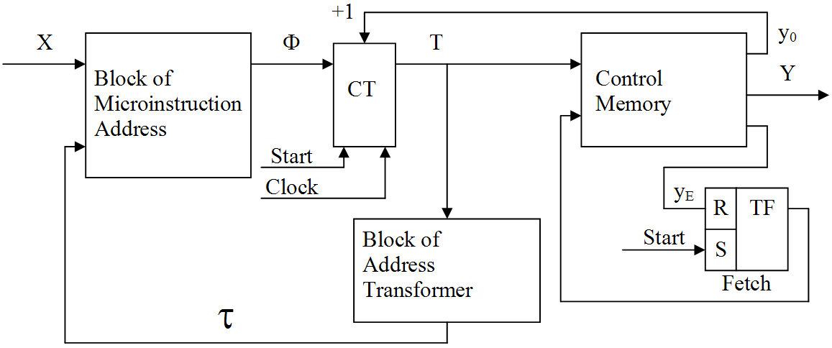
Fig. 1. Structural diagram of CMCU U₁

The pulse Start causes loading of the first microinstruction address into a counter CT and set up of fetch flip-flop TF. If Fetch = 1, then microinstructions can be read out the control memory CM. If a current microinstruction does not correspond to OLC output, then a special variable y₀ is formed together with microoperations $Y_{q}⊆Y$. If y₀ = 1, then content of CT is incremented according to the addressing mode (2). Otherwise, the block of microinstruction address BMA generates functions
$$Φ=Φ\left(τ,X\right)$$ | (4)
to load the next microinstruction address into CT. In the same time, the block of address transformer BAT generates functions
$τ=τ\left(T\right)$. | (5)
If the output of OLC $α_{g}∉C_{1}$ is reached, then $y_{E}=1$. It causes cleaning of TF and operation of CMCU U₁ is terminated.
Such organization of CMCU permits decrease of the number of terms in functions $Φ$ from H₁ till H₀, where H₁, H₀ is the number of terms for equivalents finite state machines (FSM) Moore and Mealy respectively. But block BAT consumes some macrocells or cells of PROM used for implementation of CM. In this article we propose some CMCU U₂, where H₂ = H₀ and block BAT consumes less hardware then its counterpart in U₁. Here H₂ means the number of terms in functions $Φ$ for CMCU U₂.

3. Main idea of proposed method
Let us point out that logic circuits for BMA, CT, TF and BAT are implemented as the parts of CPLD. To implement the CM one should use PROM chips with t outputs, where t = 1, 2, 4, 8, 16 [3, 4]. Let s address the components of OLC $α_{g}∈C_{1}$ in such manner that condition (2) takes place and maximal possible amount of classes $B_{i}∈Π_{C}$ was represented by a single generalized interval of R-dimensional Boolean space. Such addressing needs a special algorithm which should be developed.
Let $Π_{C}=Π_{A}∪Π_{B}$, where $B_{i}∈Π_{A}$ if this class is represented by one interval, and $B_{i}∈Π_{B}$ otherwise. The counter CT is a source of the codes for $B_{i}∈Π_{A}$. If condition
$$Π_{B}=0$$ | (6)
takes place, then block BAT is absent. Otherwise, only output addresses for OLC from classes $B_{i}∈Π_{B}$ should be transformed. It is enough
$$R_{2}=\left\lceil \text{log}\left(I_{B}+1\right)\right\rceil$$ | (7)
bits for such encoding, where $I_{B}=\left|Π_{B}\right|$ and 1 is added to take into account the case when $B_{i}∈Π_{A}$. Let us point out that some part of these codes can be implemented using free outputs of PROM. Let us use hot-one encoding of microoperations [2] when the CM word has N+2 bits. In this case the CM can be implemented using
$$R_{0}=\left\lceil \frac{N+2}{t}\right\rceil$$ | (8)
chips with enough amount of cells (not less than M). Obviously, that R₃ outputs of PROM are free, where
$$R_{3}=R_{0}∗t−N−2$$ | (9)
If condition
$R_{3}≥R_{2}$, | (10)
takes place, then CM is a source of the codes for $B_{i}∈Π_{B}$ and block BAT is absent. Otherwise, we can represent $Π_{B}$ as $Π_{E}∪Π_{D}$, where $I_{E}=\left|Π_{E}\right|, I_{D}=\left|Π_{D}\right|$. In this case
$I_{E}=2^{R_{3}}−1$, | (11)
$R_{4}=\left\lceil {\text{log}}_{2}(I_{D}+1)\right\rceil$. | (12)
The value I_{E} is decremented to represent the situation that $B_{i}∈Π_{E}$. The value of I_{D} is incremented to show the case that $B_{i}∈Π_{D}$. Thus, only the outputs of OLC $α_{g}∈B_{i}$ should be transformed, where $B_{i}∈Π_{D}$. In common case when $Π_{i}≠∅\left(i=A,E,D\right)$ the following CMCU U₂ is proposed for interpretation of GSA $Γ$ (Fig. 2).
In CMCU U₂, the codes $K_{A}\left(B_{i}\right)$ of classes $B_{i}∈Π_{A}$ are represented by variables $T_{r}∈T$; the codes $K_{E}\left(B_{i}\right)$ of the classes $B_{i}∈Π_{E}$ are represented by variables $v_{r}∈V$, where $\left|V\right|=R_{3}$; the codes $K_{D}\left(B_{i}\right)$ of the classes $B_{i}∈Π_{D}$ are represented by variables $z_{r}∈Z$, where $\left|Z\right|=R_{4}$. In CMCU U₂, the block BMA implements functions
$Φ=Φ\left(T,Z,V,X\right)$, | (13)
and the block BAT implements functions
$Z=Z\left(T\right)$. | (14)
Let symbol $U_{i}(Γ_{j})$ stands for implementation of GSA Г_{j} by CMCU U_{i}, and symbol $Q_{i}\left(Γ_{j}\right)$ for the number of macrocells in logic circuit of the block BAT for CMCU $U_{i}(Γ_{j})$, where i = 1, 2. Let inputs of q-th macrocell of BAT receive L_{q} logical conditions and let each macrocell have S inputs. Application of the proposed method has sense if condition
$L_{q}+R+R_{3}+R_{4}≤S$, | (15)
takes place, where q = 1, … , $Q_{2}\left(Γ_{j}\right)$.
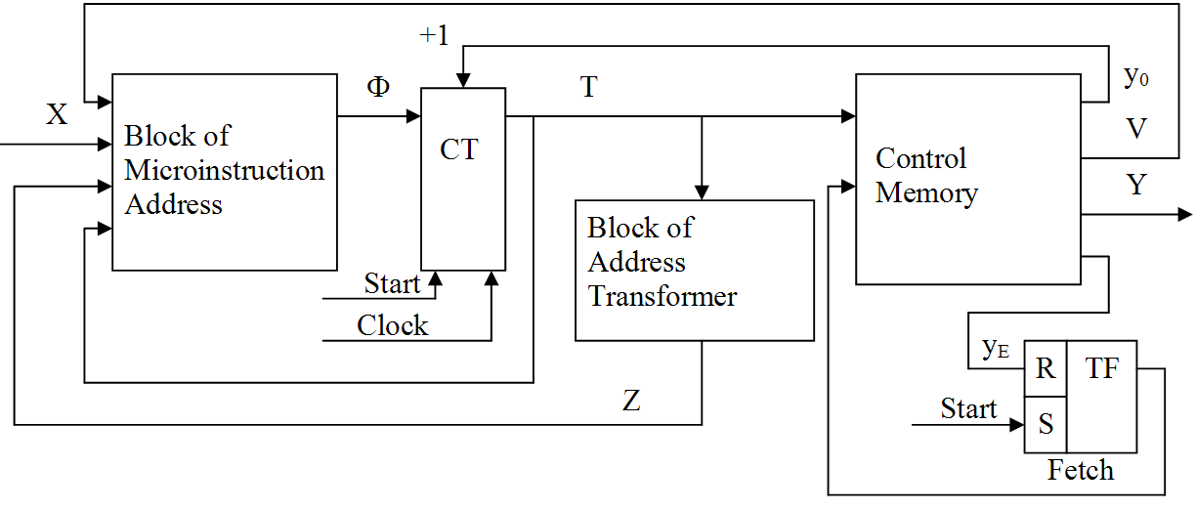
Fig. 2. Structure diagram of CMCU U₂

In this article the method of CMCU U₂ synthesis is proposed with the following steps:
- Construction of the sets C, C₁ and $Π_{C}$ for GSA Г.
- Microinstruction addressing.
- Construction of the sets $Π_{A}$, $Π_{E}$ и $Π_{D}$.
- Encoding of the classes $B_{i}∈Π_{E}∪Π_{D}$.
- Construction of the control memory content.
- Construction of transition table for CMCU.
- Construction of the table for address transformer.
- Synthesis of the logic circuit of CMCU.

4. Example of application of proposed method
Let the sets $C=\left\{α_{1},\text{.}\text{.}\text{.},α_{9}\right\}$, $C_{1}=\left\{α_{1},\text{.}\text{.}\text{.},α_{8}\right\}$ and $Π_{C}=\left\{B_{1},\text{.}\text{.}\text{.},B_{5}\right\}$ are formed for GSA Г₁, where $α_{1}=\left\langle b_{1},b_{2}\right\rangle$, $α_{2}=\left\langle b_{3},\text{.}\text{.}\text{.},b_{6}\right\rangle$, $α_{3}=\left\langle b_{7},b_{8}\right\rangle$, $α_{4}=\left\langle b_{5},\text{.}\text{.}\text{.},b_{\text{13}}\right\rangle$, $α_{5}=\left\langle b_{4},\text{.}\text{.}\text{.},b_{\text{17}}\right\rangle$, $α_{6}=\left\langle b_{\text{18}},\text{.}\text{.}\text{.},b_{\text{21}}\right\rangle$, $α_{7}=\left\langle b_{\text{22}},\text{.}\text{.}\text{.},b_{\text{25}}\right\rangle$, $α_{8}=\left\langle b_{\text{26}},\text{.}\text{.}\text{.},b_{\text{28}}\right\rangle$, $α_{9}=\left\langle b_{\text{29}},\text{.}\text{.}\text{.},b_{\text{31}}\right\rangle$, $B_{1}=\left\{α_{1}\right\}$, $B_{2}=\left\{α_{2},α_{3}\right\}$, $B_{3}=\left\{α_{4},α_{5}\right\}$, $B_{4}=\left\{α_{6},α_{7}\right\}$, $B_{5}=\left\{α_{8}\right\}$. Thus, I = 5, R₁ = 3, $τ=\left\{τ_{1},τ_{2},τ_{3}\right\}$, M = 31, R = 5.
Let us address the microinstructions using some modification of algorithm from [2]. Now have $A\left(b_{1}\right)=\text{00000},…,A\left(b_{\text{25}}\right)=\text{110000}$, $A\left(b_{\text{26}}\right)=\text{11100},…,A\left(b_{\text{28}}\right)=\text{11110}$, $A\left(b_{\text{29}}\right)=\text{11001},…,A\left(b_{\text{31}}\right)=\text{11011}\text{.}$ Let us construct the Karnaugh map marked by the variables $T_{r}∈T=\left\{T_{1},\text{.}\text{.}\text{.},T_{5}\right\}$ (Fig. 3). This map contains outputs of OLC $α_{g}∈C$ and code space intervals corresponding to the classes $B_{i}∈Π_{C}$.
The sign * in this map stands for the case when a vertex $b_{q}∈E_{1}$ with address A(b_{q}) is not the output of OLC $α_{g}∈C_{1}$. The following code intervals can be derived from Fig. 3: class B₁ corresponds to interval 0000*, class В₂ to 001**, class В₃ to 01*** and 10000, В₄ to 101** and 11000, class В₅ to 111**. Let us point out that $α_{9}∉C_{1}$ and class $B_{6}=\left\{α_{9}\right\}$ is not considered here.
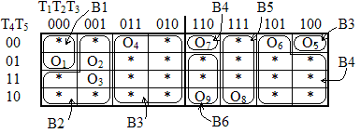
Fig. 3. Karnaugh map for outputs of OLC

The obtained intervals determine the sets $Π_{A}=\left\{B_{1},B_{2},B_{5}\right\}$ and $Π_{B}=\left\{B_{3},B_{4}\right\}$. Let N=13 for GSA Г₁ and t=4 for PROM chips in use. In this case we can get R₃ = 1 (from (9)) and R₂ = 2 (from (7)). Thus, condition (10) is violated and block BAT should be used in CMCU U₂(Г₁). Let $Π_{E}=\left\{B_{3}\right\}$, then $Π_{D}=\left\{B_{4}\right\}$. Thus, the sets $Π_{A}$, $Π_{E}$ and $Π_{D}$ are constructed.
Obviously, $V=\left\{v_{1}\right\},Z=\left\{z_{1}\right\}$, let $K_{E}\left(B_{3}\right)=1,K_{D}\left(B_{4}\right)=1$. As it was found, $K_{A}\left(B_{1}\right)=\text{0000}\text{*,}K_{A}\left(B_{2}\right)=\text{001}\text{**,}K_{A}\left(B_{5}\right)=\text{111}\text{**}$.
The content of control memory is constructed in a trivial way [2] and this step is here omitted. Let us point out, that the cells with addresses 10100 and 11000 include the variable v₁ = 1.
Let transitions for classes В₂, В₃, В₄ are described by the following system of generalized transition formula [7]:
$$\begin{aligned}B_{2}→x_{3}b_{9}∨\overline{x_{3}}b_{\text{26}}; \\ B_{3}→x_{1}b_{\text{18}}∨\overline{x_{1}}x_{2}b_{\text{20}}∨\overline{x_{1}}\overline{x_{2}}b_{\text{26}}; \\ B_{4}→x_{5}b_{\text{27}}∨\overline{x_{5}}b_{5}\text{.}\end{aligned}$$ | (16)
The system (16) determines the fragment of transition table with 7 lines (Table 1).
Table 1.
Fragment of transition table for CMCU U₂(Г₁)
$$B_{i}$$ | $$K_{A}\left(B_{i}\right)$$ | $$K_{E}\left(B_{i}\right)$$ | $$K_{D}\left(B_{i}\right)$$ | $$b_{q}$$ | $$A\left(b_{q}\right)$$ | $$X_{h}$$ | $$Φ_{h}$$ | h
$$B_{i}$$ | T₁T₂T₃T₄T₅ | V₁ | Z₁
B₂ | 001** | 0 | 0 | b₉ | 01000 | $$x_{3}$$ | D₂ | 1
 |  |  |  | b₂₆ | 11100 | $$\overline{x_{3}}$$ | D₁D₂D₃ | 2
B₃ | ***** | 1 | 0 | b₁₈ | 10001 | $$x_{1}$$ | D₁D₅ | 3
 |  |  |  | b₂₀ | 10011 | $$\overline{x_{1}}x_{2}$$ | D₁D₄D₅ | 4
 |  |  |  | b₂₆ | 11100 | $$\overline{x_{1}}\overline{x_{2}}$$ | D₁D₂D₃ | 5
B₄ | ***** | 0 | 1 | b₂₇ | 11101 | $$x_{5}$$ | D₁D₂D₃D₅ | 6
 |  |  |  | b₅ | 00100 | $$\overline{x_{5}}$$ | D₃ | 7

Connection of this table and system (16) is a transparent one. Let us point out that the case v₁ = z₁ = 0 corresponds to classes $B_{i}∈Π_{A}$. Otherwise, $B_{i}∈Π_{E}∪Π_{D}$ and content of the column $K_{A}\left(B_{i}\right)$ is ignored. This table is a base for construction of the system (13). For example, the following parts of SOP can be derived from Table 1:
$$\begin{aligned}D_{1}=\overline{T_{1}}\overline{T_{2}}T_{3}\overline{v_{1}}\overline{z_{1}}\overline{x_{3}}∨v_{1}\overline{z_{1}}∨\overline{v_{1}}z_{1}x_{5}; \\ D_{2}=\overline{T_{1}}\overline{T_{2}}T_{3}\overline{v_{1}}\overline{z_{1}}∨v_{1}\overline{z_{1}}\overline{x_{1}}\overline{x_{2}}∨\overline{v_{1}}z_{1}x_{5}\text{.}\end{aligned}$$
The table of BAT is constructed for the classes $B_{i}∈Π_{D}$. In our particular case this table includes 2 lines (Table 2).
Table 2
Table of the block BAT for CMCU U₂(Г₁)
$$α_{g}$$ | $$A\left(O_{g}\right)$$ | $$B_{i}$$ | $$K_{D}\left(B_{i}\right)$$ | $$Z_{j}$$ | j
$$α_{6}$$ | 10100 | B₄ | 1 | z₁ | 1
$$a_{7}$$ | 1000 | B₄ | 1 | z₁ | 2
This table is the base to construct the system (14). In our case this system represented as the following one:
$$z_{1}=T_{1}\overline{T_{2}}T_{3}\overline{T_{4}}\overline{T_{5}}∨T_{1}T_{2}\overline{T_{3}}\overline{T_{4}}\overline{T_{5}}\text{.}$$
Synthesis of logic circuit of CMCU U₂(Г_{j}) is reduced to implementation of systems (13)-(14) using PAL macrocells and control memory using PROM chips. These problems are well-known [2,6] and they are not discussed in our article.
Let us point out that table of Block BAT for CMCU U₁(Г₁) includes 8 lines and R₁ = 3. Let macrocell PAL has q=3 terms, then block BAT of CMCU U₂(Г₁) is implemented using Q₂(Г₁) = 1 macrocells. If the classes $B_{i}∈Π_{C}$ of CMCU U₁(Г₁) is encoded in the following way: К(В₁) = 000,…, К(В₅) = 100, then Q₁(Г₁) = 4 (if q = 3). In both cases the block BMA is implemented with the same amount of macrocells.

5. Conclusion
The proposed method targets on decrease in hardware amount (the number of macrocells) in the circuit of address transformer. In this case the number of macrocells in the block of microinstruction address as well as the number of PROM chips in the block of control memory does not change. The method is based on use of three sources of the codes of pseudoequivalent OLC classes. It is possible due to a wide fan-in of industrial PAL macrocells. Let us point out that block BAT can be eliminated if one of the conditions (6) or (10) takes place.
Our experiments show that the number of macrocells in the block BAT is decreased up to 60-70% in comparison with known methods of CMCU design. The total decrease in hardware amount is up to 10% in comparison with CMCU U₁(Г₁).

References: 1. DeMicheli G. Synthesis and Optimization of Digital Circuits. – McGraw-Hill, 1994. – 636 pp. 2. Баркалов А.А. Синтез устройств управления на программируемых логических устройствах. – Донецк: ДНТУ, 2002. – 262 с. 3. Altera devices. http://www.altera.com/products/devices/common/dev-family_overview.html. 4. Xilinx CPLDs http://www.xilinx.com/products/silicon_solutions/cplds/index.htm. 5. Грушницкий Р.И., Мурсаев А.Х., Угрюмов Е.П. Проектирование систем с использованием микросхем программируемой логики. – СПб: БХВ. – Петербург, 2002. – 608 с. 6. Соловьев В.В. Проектирование цифровых схем на основе программируемых логических интегральных схем. – М.: Горячая линия-ТЕЛЕКОМ, 2001. – 636 с.
7. Baranov S. Logic Synthesis for Control Automata. – Kluwer Academic Publishers, 1994. – 312 pp.

