Credit Market Liberalization Reform Outcomes

Zukhba D.S.
Deputy Director on International Relations
Institute of Economics and Management
Donetsk National Technical University
Shpynova K.V.
Student majoring in International Economics, DonNTU

Introduction. Many economists (Kaminsky and Reinhart, 1999; Bhagwhati, 1998; Gupta et al., 2009; Quinn and Toyoda, 2009 and others) have long debated over the effects of financial liberalization on economic growth. Financial liberalization may have a positive impact on growth through its effect on efficiency of resources allocation in economy (quality effect), rather than through the quantity of mobilized capital (quantity effect). Financial liberalization is strongly associated with an increase in the role of market and a reduction in the role of government in credit allocation. Free access to international capital markets increases competition in domestic financial markets. Domestic financial institutions, facing competition from international players, become reluctant to extend credit to inefficient producers. Mobile capital forces the government to maintain macroeconomic prudence, further reducing the government’s ability to intervene in the domestic credit market [1]. Thus, the result of the liberalization of the financial sector and the main feature of world economy globalization is the international movement of capital that is implemented in the international credit market. This market, being the most dynamic sector of the international market of loan capital, is very susceptible to changes in the global economic space. All this makes it important to analyse credit market liberalisation in order to understand better the reasons for current economic situation in the world.
Results and analysis. The process of credit market liberalization was affected by number of factors such as timing of the reform, initial reform conditions and others, which led to cross-country differences in credit market. Building a sound and effective financial system cannot be achieved overnight, but rather requires a complex of short-term policy measures, medium-term reform processes and long-term institution building. Abolishing interest rate ceilings and floors, eliminating directed credit programs and imposing transparency requirements are policy reforms that can be legislated speedily, regulated and implemented, as the experience in many developed and developing countries has shown. Other processes can take longer, such as privatizing government-owned banks and establishing a system of credit information sharing. Reforming legal systems and building regulatory and supervisory capacity are long-term institution building processes [2].
International credit markets were highly integrated in the 1890s but were disrupted by two World Wars and the Great Depression. International investment, relative to output, reached the lowest level during the 1950s and 1960s.
After the first oil shock of 1973, the developed economies experienced a dramatic decline in their economic growth and labor productivity growth. Since the mid-1970s the productivity decline triggered a wide range of policy responses, including credit market liberalization (CML) across a wide range of countries. The CML reforms were initiated in the US, followed by the UK and other developed economies in the early 1980s and were imitated by the new democracies and many developing countries with an extensive set of labor-, capital- and product-market reforms in 1990s.
Using the strategy proposed by Estevadeordal and Taylor [10] it is possible to identify 4 distinct categories of countries:
1. Reformers in the first period - the early reformers (1975-1990): New Zealand etc.
2. Reformers in the second period - the late reformers (1990-2005): Turkey, Australia, South Africa etc.
3. Reformers in both periods - the “marathon” reformers (1975-2005): USA, United Kingdom, Germany, Canada etc.
4. Non-reformers in both periods: Singapore, Jordan, Jamaica
Developed and developing countries around the world liberalized their financial systems, allowing markets to set interest rates, eliminating control so that capital could flow freely across borders, and open their doors to foreign financial firms. However, there were significant differences in the pace and scale of reform. The given graph observes the difference of the GDP growth in various regions of the world.
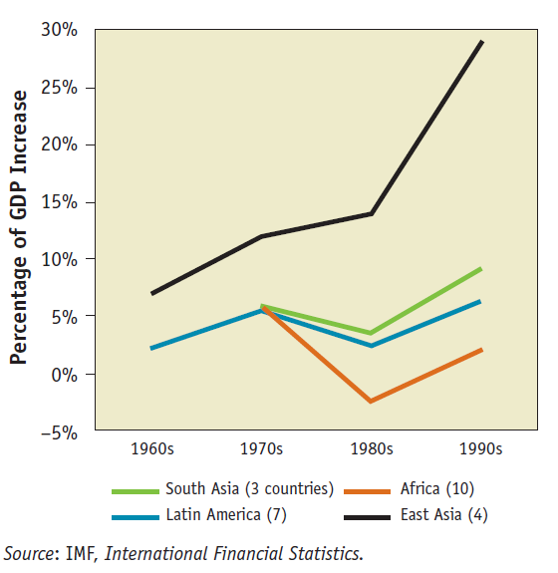
Figure 1. Average Deposits/GDP in Major Countries Increase, by Regions, 1960s – 90s

The financial repression that prevailed in developing and transition countries in the 1970s and 1980s reflected a mix of state-led development, nationalism, populism, politics, and corruption. The financial system was treated as an instrument of the treasury: governments allocated credit at below market interest rates, used monetary policy instruments and state-guaranteed external borrowings to ensure credit supplies and public sector firms, and directed part of the resources that had been left to sectors they favored.
In 1974-1975 in the U.S. there was a drop in production, unemployment, chronic underutilization of production facilities with a chronic increase in prices. This phenomenon is called stagflation. At that time the model of state regulation reduced its strength. According to the monetary concept, which replaced the neo-Keynesianism, the government of the US began to focus on the monetary authorities and use the monetary policy to achieve sustainable economic growth.
Financial regulations generally fall into two broad categories [3]:
1.“rate/ quantity” regulations on bank deposits and loans, including ceilings on bank deposit rates and quatitative measures that have similar effects (credit ceilings, capital controls, etc.);
2.“powers” regulations governing the extensiveness of activities of individual financial institutions, which are authorised to carry out various borrowing and lending functions, can participate in the payments system, or in securities underwriting, equities, insurance, etc.
The credit market liberalization reforms were followed by other developed economies in the early 1980s. The US, the UK and Canada rapidly removed rate/quantity and powers regulations. While some powers regulations are still applying, their financial systems may be described as highly competitive. Japan in 1980s removed capital control at the beginning of the decade and gradually introduced market alternatives to regulated bank deposits throughout the decade. Developments proceeded more cautiously in France and Italy, with capital controls being removed only gradually throughout the 1980s and rate/quantity and powers regulations were still applied fairly extensively in 1990s. While Germany was one of the first countries to remove rate/quantity regulations in the 1960s and 1970s, it was relatively slow to implement “powers” deregulation. As a result, competition between German banks remained muted, and short-term financial instruments paying market returns were readily available as alternatives to bank deposits throughout the 1970s and 1980s.
Australia, New Zealand and most of the Scandinavian countries were prominent amongst the smaller economies that had moved more quickly in the direction of financial liberalisation in the mid-1980s and 1990s. Others such as Greece, Portugal and Spain retained better regulated financial systems.
Before the ﬁnancial market liberalizations of the late 1980s and early 1990s the peaks and troughs of some emerging countries (Argentina, Brazil, Mexico, Chile, Korea, Thailand) were not aligned at all. Furthermore, they were not aligned with those identiﬁed for the US. In fact, all six countries seemed to follow widely diﬀerent patterns before 1990. After 1990, a time when these countries either initiated, or were about to launch their reforms, individual cycles began to exhibit evident co-movement. This ﬁnding suggests that in the post-reform period, the emerging markets were becoming signiﬁcantly more integrated with each other [4].

Table 1. Dates of the Peaks and Troughs
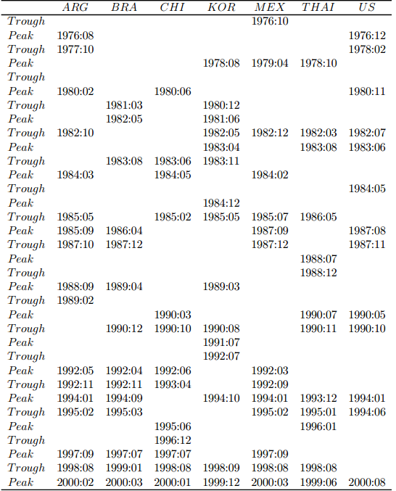

1990 marks an important change in economic history with the start of many market-oriented reforms across a wide range of economies. The credit market liberalization that took place in the developing countries in the 1990s was a part of the general move toward giving markets a greater role in development. It was also a reaction to several factors specific to finance: the costs, corruption, and state-led development. The earliest policy changes focused generally on interest rates. In many instances governments raised interest rates to mobilize more resources needed to finance budget deficits and to enable the private sector to play a greater role in development. The countries began to admit foreign currency deposits to attract offshore funds and foreign currency holdings into the financial system as well as allow residents legal access to foreign currency assets.

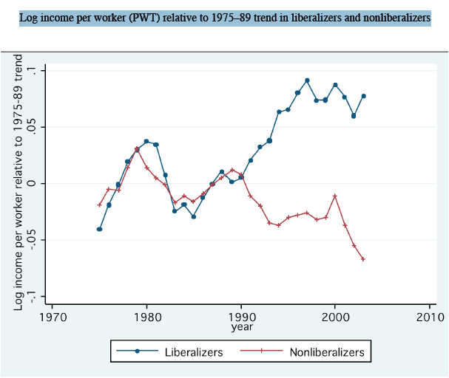
Figure 2. The Great Liberalization and Growth Accelerations

Countries with better developed financial systems, i.e. financial markets and institutions that more effectively directed society’s savings to their most productive use, experienced faster economic growth. Countries with higher credit levels to the private sector in relation to GDP were experiencing higher average annual real GDP per capita growth rates over the period from 1980 to 2003.
There are a number of channels through which financial liberalization may affect growth. Foreign investors, being interested in improved benefits of diversification, will increase local equity prices permanently by reducing the capital and increasing investment cost. If this additional investment is efficient, then economic growth should increase [5].
Nowadays it is observable that the largest national credit markets are in the USA, China, Japan, Germany, France and the United Kingdom.

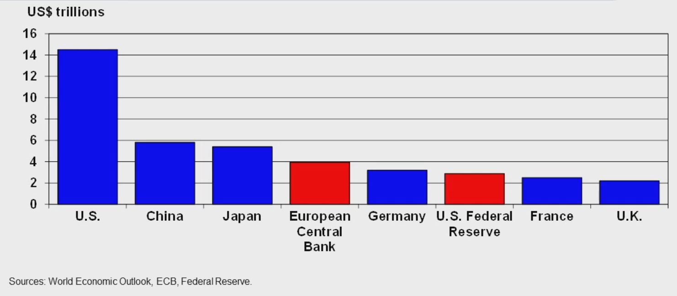
Figure 3. The Central Banks’ Assets on the Largest Credit Markets

The following table shows such indexes as: Gross domestic product (GDP), GDP per capita, Gross national income (GNI), real GDP growth and the household disposable income. They identify the level of development of the economy.

Table 2. Economic indexes in 2010
Countries | Gross domestic product (GDP)  (Bln USD current PPPs) | GDP per capita  (USD current PPPs) | Gross national income (GNI) per capita (USD current PPPs) | Real GDP growth  (annual growth %) | Household disposable income  (annual growth %)
The US | 14582 | 47024 | 45567 | 2.9 | 0.9
Germany | 3071.3 | 37567 | 38115 | 3.6 | -1
The UK | 2233.9 | 35917 | 36427 | 1.4 | 1
France | 2194.1 | 33835 | 34453 | 1.5 | 1,8
Japan | 4301.9 | 33772 | 32896 | 3.9 | …
Australia | 915.7 | 40644 | 38376 | 2.6 | …
Austria | 332.9 | 39768 | 39464 | 2 | …
Turkey | 1116 | 15320 | … | 8.9 | …
Financial liberalization leads to a one percent increase in annual real per capita GDP growth over a five year period, and finds this increase statistically significant. This result is robust to a wide variety of experiments including: an alternative set of liberalization dates, different groupings of countries, regional indicator variables, different weighting matrices for standard errors calculation and four different time-horizons for measuring economic growth [6]. In many cases the countries that lagged behind with their liberalization reforms prior to 1990 but accelerated their reforms after 1990 had lower per capita GDP levels than the early reformers and the “marathon” reformers.

Figure 4. The Most Developed Economies
(based on the GDP per capita index in the 2010)

Conclusion. CML reforms played a significant role in credit markets developing as well as the whole economies. They gave countries an access to larger amounts of international financial flows, in order to attract a part of the substantially increased flows of financial capital to the so-called “emerging markets” since the late-1970s. International capital flows have increased substantially over the past years, especially portfolio flows and foreign direct investment. More and more emerging markets have decided to open their economies for inward and outward equity and debt investment. Cross-country comparisons have shown that countries experience higher capital inflows, lower capital cost for enterprises raising funds through stock exchanges, higher investment growth, improved capital allocation and ultimately higher GDP per capita growth rates after making their economies accessible to equity inflows (Bekaert and Harvey, 2003). Among countries with functioning financial markets, financial liberalization leads to faster average long-run growth. That is why proponents of liberalization point out that financial development and credit market liberalization are strongly associated with economic growth.

References
1. Kukenova Madina (2011): Financial Liberalization and Allocative Efficiency of Capital, The World Bank: Policy Research Working Paper 5670.
2. Beck Thorsten (2006): Creating an Efficient Financial System: Challenges in a Global Economy, World Bank Policy Research Working Paper 3856.
3. Blundell-Wignall Adrian; Browne Frank; Manasse Paolo: Monetary Policy in Liberalised Financial Markets, OECD Economic Studies No. 15, Autumn 1990.
4. Edwards Sebastian; Biscarri Javier Gomez; Perez de Gracia Fernando: Stock Market Cycles, Financial Liberalization and Volatility, National Bureau of Economic Research: Working Paper 9817, July 2003.

5. Geert Bekaert and Campbell R. Harvey: Economic Growth and Financial Liberalization, NBER Reporter: Spring 2001: http://www.nber.org/reporter/spring01/bekaert.html

6. Geert Bekaert; Campbell R. Harvey; Christian Lundblad: Does Finantial Liberalization Spur Growth?, National Bureau of Economic Research: Working Paper 8245, April 2001.

7. Aaron Tornel; Frank Westermann; Lorenza Martinez: The Positive Link Between Financial Liberalization Growth and Crises, National Bureau of Economic Research: Working Paper 10293, February 2004.

8.http://www.milkeninstitute.org/events/gcprogram.taf?function=detail&eventid=gc12&EvID=3148

9. Alessandra Bonﬁglioli: How Does Financial Liberalization aﬀect Economic Growth?, CREI and Universitat Pompeu Fabra, September 20, 2005.

10. Antoni Estevadeordal; Alan M. Taylor: Is the Washington Consensus Dead? Growth, Openness, and the Great Liberalization, 1970s-2000s, National Bureau of Economic Research: Working Paper 14264, August 2008.

11. http://www.oecd-ilibrary.org/statistics

12. http://www1.worldbank.org/prem/lessons1990s/chaps/07-Ch07_kl.pdf

