Khomenko Yana Vladymyrovna,
Head of The Department of International Business Activity, DonNTU, Donetsk,Ukraine
Poddubnaya Olga Artyomovna,
Student of group IES-07b, DonNTU, Donetsk, Ukraine,
poddubnaya-olga@yandex.ru

SENSITIVITY ANALYSIS AS A TOOL FOR RISK MANAGEMENT

Introduction During the economic crisis the economy of every country is not stable. It is particularly difficult to operate for enterprises. The uncertainty and instability of the economy do not allow to plan the future. In the economic activity of every enterprise there are plenty of investment projects. Nowadays the demand for investment resources is higher than its supply. That is why in order to get investment resources, the project must be profitable. Every investment project can be exposed to variable factors, which can affect the profitability. To define the impact of the variable factors on the profitability of the project, decision makers use sensitivity analysis as a tool for risk management.
Sensitivity analysis is a practical way of showing the effects of uncertainty by varying the values of the key factors and showing the resulting effect on the project. The objective of this analysis is to establish which of the factors affect the project most. In other words sensitivity analysis helps to indicate why a project might fail. But not always sensitivity analysis defines the factors which can impact on the viability of the project.
The research object is sensitivity analysis as an effective tool for decision-makers in risk management.
The subject of this study is the level of efficiency of the sensitivity analysis application in different spheres of the economy.
The purpose of this study is to find out how efficient sensitivity analysis is in different spheres of the economy and to identify the advantages and disadvantages of application of sensitivity analysis.
The sensitivity analysis application in different spheres of the economy has been described by many scientists, such as J. Arnold [1], D. Cadman [2], C. Drury [3], T. Lucey [4], H. Marshall [5], D. Pannell [6].
Theoretical framework. The application of sensitivity analysis has been grouped by Pannell into four main categories [6]: decision making or development of recommendations for decision makers, communication, increased understanding or quantification of the system, and model development (see Table 1).

Table 1. Uses of sensitivity analysis [6]
1. | Decision Making or Development of Recommendations for Decision Makers
1.1 | Testing the robustness of an optimal solution
1.2 | Identifying critical values, thresholds or break-even values where the optimal strategy changes
1.3 | Identifying sensitive or important variables
1.4 | Investigating sub-optimal solutions
1.5 | Developing flexible recommendations which depend on circumstances.
1.6 | Comparing the values of simple and complex decision strategies
1.7 | Assessing the "riskiness" of a strategy or scenario
2. | Communication
2.1 | Making recommendations more credible, understandable, compelling or persuasive
2.2 | Allowing decision makers to select assumptions
2.3 | Conveying lack of commitment to any single strategy
3. | Increased Understanding or Quantification of the System
3.1 | Estimating relationships between input and output variables
3.2 | Understanding relationships between input and output variables
3.3 | Developing hypotheses for testing
4. | Model Development
4.1 | Testing the model for validity or accuracy
4.2 | Searching for errors in the model
4.3 | Simplifying the model
4.4 | Calibrating the model
4.5 | Coping with poor or missing data.
4.6 | Prioritising acquisition of information
When sensitivity analysis is used, first of all it is necessary to define variable parameters to which the key parameter is the most sensitive. If parameters are uncertain, sensitivity analysis can give such information as [6]:
- How robust the optimal solution is in the face of different parameter values (use 1.1 from Table 1);
- Under what circumstances the optimal solution would change (uses 1.2, 1.3, 1.5);
- How the optimal solution changes in different circumstances (use 3.1);
- How much worse off the decision makers would be if they ignored the changed circumstances and stayed with the original optimal strategy or some other strategy (uses 1.4, 1.6).
After doing this analysis the decision maker can make the best decision. The higher the level of the sensitivity to the factors of environment is, the riskier is the project. If there is no uncertainty about parameters sensitivity analysis can be used to check the profitability of the project and its value in the future. Sensitivity analysis can be used to assess the "riskiness" of a strategy or scenario (use 1.7). It is also possible to explicitly represent the trade-off between risk and benefit within the model [6].
Thus, it can be said that sensitivity analysis is a universal tool for risk management which helps decision makers to take a right decision and to assess the level of risk. When the level of risk is assessed, it will be easier to prepare for “what if” question and to avoid a negative consequences. For investors it helps to forecast the future of the viability of the project.
Results. Sensitivity analysis can be successfully used in the engineering economics. It can be shown by means of research made by Marshall [5]. This research reveals the following: when the certain equipment should be installed, the investor can choose the most profitable variant.
According to Marshall’s research, sensitivity of the net savings to the time is estimated. Initial conditions for research are: there is an old heating system, which must be replaced by the new one. There are 2 variations: high-efficiency gas heating system and low-efficiency gas heating system. The owner’s task is to choose one of the most effective heating systems, more than that not to waste his savings. Marshall assessed the level of sensitivity of net savings to the time. The results of research can be seen in figure 1.
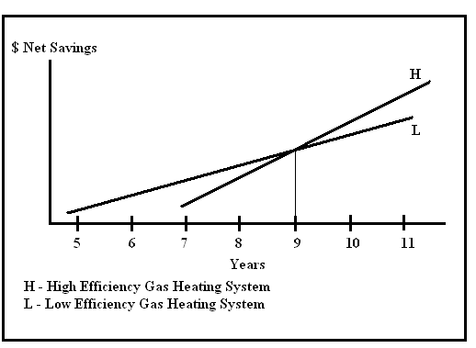

Figure 1. Sensitivity of net savings to time [5]

According to figure 1, Marshall made the conclusion that the low-efficiency gas heating system can be profitable only in case the owner is planning to hold the house up to 9 years. If he is planning to hold the house more than 9 years, then high-efficiency gas heating system will be more effective [5]. Thus, net savings are sensitive to uncertainty of how long the owner is planning to hold the house.
Analyzing the advantages of this example it can be said that sensitivity analysis helps a decision maker to choose the most profitable variant. The disadvantage of this analysis is the ignoring of the level of progress in the production of heating system.
To conclude, the application of sensitivity analysis in this case was quite effective. But if the owner should decide immediately which heating system must be installed and he does not know how long he is planning to hold the house, the application of sensitivity analysis will be not efficient.
Sensitivity analysis is used in economics to show the profitability of the investment of the future and the factors which can impact on the profitability. The next example where sensitivity analysis can be used is commercial building investment. According to the research of Marshall the main task is to identify the level of sensitivity of AIRR to the following variables [5]:
- Project life (PL);
- Reinvestment rate (RR);
- Operation, maintenance and replacement costs (OM&R).
The results of his research can be seen in figure 2.

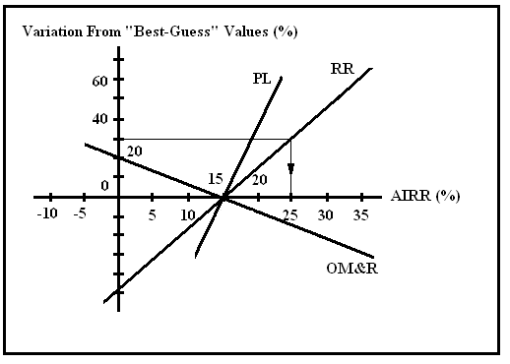

Figure 2. Sensitivity of the adjusted internal rate of return to variations in uncertain variables [5]

The conclusion was the following: the change of OM&R by 1% can impact on AIRR more than the change of RR and PL by 1%. At the same time the change of RR by 1% can impact on AIRR more than the change of PL by 1%. Thus, the less the slope of OM&R, RR and PL, the more sensitive AIRR is to these variables [5].
The advantages of the sensitivity analysis application in this project are:
- Sensitivity analysis is an excellent technique which helps to anticipate negative consequences on the project, to defend it and to prepare for “what if” question;
- Sensitivity analysis can be used on any measure on project worth;
- Sensitivity analysis enables to show the measure of response on the most sensitive variables.
Thus, it can be seen from this example during sensitivity analysis, variable parameters were found that can affect the profitability of the project. That is why it is not difficult to predict the best and the worst forecast in case some variable parameters are changed.
The financial and economic benefit-cost analysis of water supply projects (WSPs) is based on the forecast of quantifiable variables such as demand, costs, water, availability and benefits [7]. The effect of the likely changes on the viability of the WSPs was researched by the Asian Development Bank.
The variable parameters which can have impact on the profitability and the viability of the project most can be seen in table 2.
According to the calculations in the research it can be revealed that IRR is the most sensitive to investment costs. When investment costs change by 1%, then the key parameter changes by 13.3% [7].
There are some advantages of the application of sensitivity analysis:
- Sensitivity analysis can be used when there is little time for more sophisticated technique;
- Sensitivity analysis shows the effect of variable factors on project outcome.

Table 2. Variables in water supply projects to be considered in sensitivity analysis [7]

Possible Key Variables | Quantifiable Variables | Underlying Variables
Water Demand | - Population growth  - Achieved Coverage  - Household Consumption  - Non Domestic Consumption  - Unaccounted for Water | - Price Elasticity  - Income Elasticity
Investment Costs (Economic & Financial) | - Water Demand  - Construction Period  - Real Price  - Conversion Factors
O&M Costs | - Personnel Costs (wages/No. of stuff, etc.)  - Cost of Energy  - Cost of Maintenance  - Efficiency of Utility
Financial Revenues | - Quantity of Water Consumed  - Service Level  - Income From Connection Fees | - Water Tariffs
Economic Benefits | - Water Demand  - Resource Costs Savings | - Willingness to Pay
Cost Recovery | - Water Tariffs  - Subsidies

However there is one disadvantage: a lot of calculations have been done which make this analysis more complicated.
In this project the great amount of variable parameters was taken into consideration. It was defined that some of them can negatively impact on the viability of the project. In this case sensitivity analysis helped to find out how the profit will be changed if some variable parameters are changed.

Sensitivity analysis can be successfully used in agricultural economics. It can be shown by means of research made by Pannell [6]. This research presents an optimal allocation of land to production of the four products in which the entrepreneur will maximize his profit. Sensitivity of the price of wheat to the distribution of areas under crops is assessed in the research. There are some variable parameters:
- Wheat grain;
- Lupin grain;
- Pea grain;
- Wool production.
According to Pannell’s research sensitivity of the price of wheat to the variable parameters can be seen in figure 3.

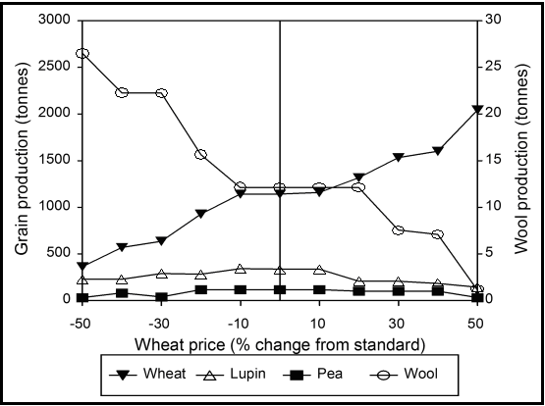

Figure 3. The allocation of land to production of each of the four products [6]

This graph reveals that the main effect of increasing of wheat price is to increase wheat production at the expense of wool. There are also smaller changes in the production of lupin grain and pea grain. According to figure 3, the function of the wheat production is inversely proportional to the function of wool production. It denominates that the lesser slope of wool production function, the more sensitive is the price of wheat to this variable.
In the application of sensitivity analysis in this case there are some disadvantages:
- Sensitivity analysis does not include the demand for product;
- Sensitivity analysis does not include some unfavorable weather conditions for the growth of grain.
Thus, in this project, where sensitivity analysis was used, some factors were not taken into consideration. Such a factor as weather conditions can affect the yield most. That is why it is essential to analyze the group of factors which will impact on the yield.
Conclusion. It is necessary to admit that decision-making as to any project implementation is impossible without assessing possible threats and risks that can affect the profitability of the project in the future. In order to predict the conduct of the projects in the future it is necessary to analyze the group of factors which can affect the project. However, the effect of variable factors on the investment project can vary, because of which it is difficult to forecast the profitability of the project accurately.
As it can be seen from the examples mentioned above, sensitivity analysis can be used in different spheres of the economy. In this paper several examples were regarded in which the practical application of sensitivity analysis in the real economy was shown. The efficiency of this analysis was defined in each project. Some projects where sensitivity analysis is the most efficient are the following: commercial building investment and water supply projects. This is explained by the fact that the great amount of factors which can affect the project were taken into consideration. In other projects which were presented in this paper the level of effectiveness is moderate, because not all factors can be taken into consideration.

References
1. Arnold J., Turley S. (1996) Accounting for management decisions, 3d ed., Prentice Hall Europe.
2. Cadman D., Topping R. (1995) Property Development, 4th ed., E&FN Spon, London.
3. Drury C. (1992) Management and Cost Accounting, 3d ed., Chapman&Hall, London.
4. Lucey T. (1996) Management Accounting, 4th ed., DP Publications, London.
5. Marshall H.E. (1995) The Engineering Handbook, 2d ed., CRC Press, available at: <http://www.bfrl.nist.gov/oae/publications/books/sa187.pdf>, last viewed: 10.10.2010
6. Pannell D.J. (1997) Sensitivity Analysis: strategies, methods, concepts, examples available at: <http://cyllene.uwa.edu.au/~dpannell/dpap971f.htm> last viewed: 10.10.2010
7. Asian Development: Bank Handbook for the economic analysis of water supply projects available at: <http://www.adb.org/Documents/Handbooks/Water_Supply_Projects/Chap7-r6.PDF> last viewed: 10.10.2010

