***ECONOMICS***

**UDC 399.9**

**EOI**[**10.11232/2663-4139.10.11**](http://eoi.citefactor.org/10.11232/2663-4139.10.11)

**THE INFLUENCE OF THE INTERNATIONAL MONETARY FUND ON THE PROCESSES**

**AMELNYTSKA Mariia**

ORCID ID: 0000-0001-8501-3107

applicant for higher education at the Faculty of Economics and Management

*Donetsk National Technical University*

**SCIENTIFIC ADVISOR:**

**PRYDATKO Ella**

ORCID ID: 0000-0001-7561-083x

Ph.D., Associate professor, Associate Professor of the Department of Management and Financial and Economic Security

*Donetsk National Technical University*

*UKRAINE*

**Abstract.**The article provides an analysis of the activities of the International Monetary Fund from the standpoint of globalization, identifies possible areas of influence of the IMF on the regulation of globalization. The impact of the IMF's financial and credit activities on the international economy and the IMF's current lending policy is described. An analysis of the use of IMF financial assistance by countries in their economic activities.  
  
***Keywords:****International Monetary Fund; lending; financial and credit policy, world economy; financial and credit mechanisms.*

**Relevance of the research topic.** Interstate economic relations in it depend, on the one hand, on the economic national order of states, concentrated in the traditional concept of "national economy", and on the other hand, on international economic integration in the form of world economy. The leading tendency of this integration process was the liberalization of trade relations and the creation of relevant international organizations, which help to overcome trade barriers and comprehensive development of economic cooperation between countries, in particular in the field of monetary and financial relations.

**Literature review on the topic of research**. A large number of scientific works of leading experts in the field, in particular, are devoted to the study of the IMF's activities in terms of regulating the processes of globalization: J. Gold, D. Driscoll, V. Ebke, H. Kelsen, E. Kraas, M. Medina, D. Mitrani, K. Nadi, P. Pescator, R. Stone, J. Stiglitz, J. Gray and others.

**The purpose of the article** is to study the impact of the International Monetary Fund on modern processes of globalization.

**Statement of the main material.** The magnitude of the IMF is expressed through the cooperation of 189 member states, practically all civilized countries in the world, to regulate monetary relations between member states and to provide them with financial assistance in the event of a currency-related deficit, through short- and medium-term credit in foreign currency.

Subsequently, the Fund reorients itself to address the specific balance of payments problems of a group of least developed countries, which are associated with changes in trade languages, natural disasters, conflicts, economic reforms, measures to overcome poverty and stimulate economic development, restructuring of sovereign debt and foreign currencies, banks.

Nowadays, the IMF plays a significant role in ensuring global financial stability. In this context, the Fund has identified three main funding goals:

- minimizing price shocks and facilitating proper debt service;

- creating favorable conditions for attracting funding from investors and donors;

- early prevention of crises [1].

The advantage of IMF loans is the low interest rate. The real interest rate on the IMF loan is always lower than the market average and is estimated by the IMF.

In order to ensure an adequate level of transparency of activities and to maintain communications, the Fund provides access to analytical documents, recommendations, data through their placement on the pages of the official website of the WF [3]. The conclusions and recommendations of the experts of the Fund, decisions of the Board of Executive Directors of the IMF, adopted on the basis of consultations in accordance with Art. Article IV of the Agreement with the International Monetary Fund, shall be published in Article IV Staff Reports.

The IMF imposes on Member States certain responsibilities, which are mainly advisory and, in some cases, mandatory. The fulfillment of these obligations significantly affect the functioning of the system of international economic relations.

For a long time, stand-by loan agreements have been the Fund's primary credit facility for general lending. However, after the global financial crisis of 2007-2009, the IMF expanded its range of lending instruments. One of the main goals was to expand the toolbox of crisis prevention by establishing a Flexible Credit Line (GCL) and a Preventive Liquidity Support Line (LPL).

IMF loans are generally intended to assist Member States in addressing balance of payments problems, stabilizing the economy and restoring sustainable economic growth. This role in crisis management is central to IMF lending. At the same time, the global financial crisis has highlighted the need for effective global financial security systems to help countries overcome adverse shocks. As a consequence, one of the main objectives of lending reform has recently been to complement the IMF's role in crisis management with additional crisis prevention tools. Unlike development banks, the IMF does not provide loans for specific projects - the Fund's loans are granted to countries that may experience a shortage of foreign currency in order to give them time to adjust economic policies and resume growth without having to take action, damaging their economies or the economy of other Member States. In the broad definition, the IMF provides two types of lending - non-preferential interest rate loans (general terms) and poor-interest loans to poor countries with low or even zero interest rates in some cases.

In addition, the Accelerated Financing Facility (RFI) was created and can be used in a wide variety of circumstances, replacing the IMF Emergency Assistance Policy (Table 1).

   In fiscal year 2017, the Executive Board approved 5 arrangements under the IMF General Funding Mechanisms for a total of SDR 98.2 billion (US $ 134.7 billion at the exchange rate of April 28, 2017 equal to 0.729382 SDR for 1 dollar). Preventive credit agreements with the three Member States - Mexico (SDR 62.4 billion), Colombia (SDR 8.2 billion) and Poland (SDR 6.5 billion) - accounted for a percentage of such commitments . All three Flexible Credit Facility Agreements have superseded previous agreements that have been completed or terminated.

*Table 1.***Financial programs to support IMF member countries [2]**

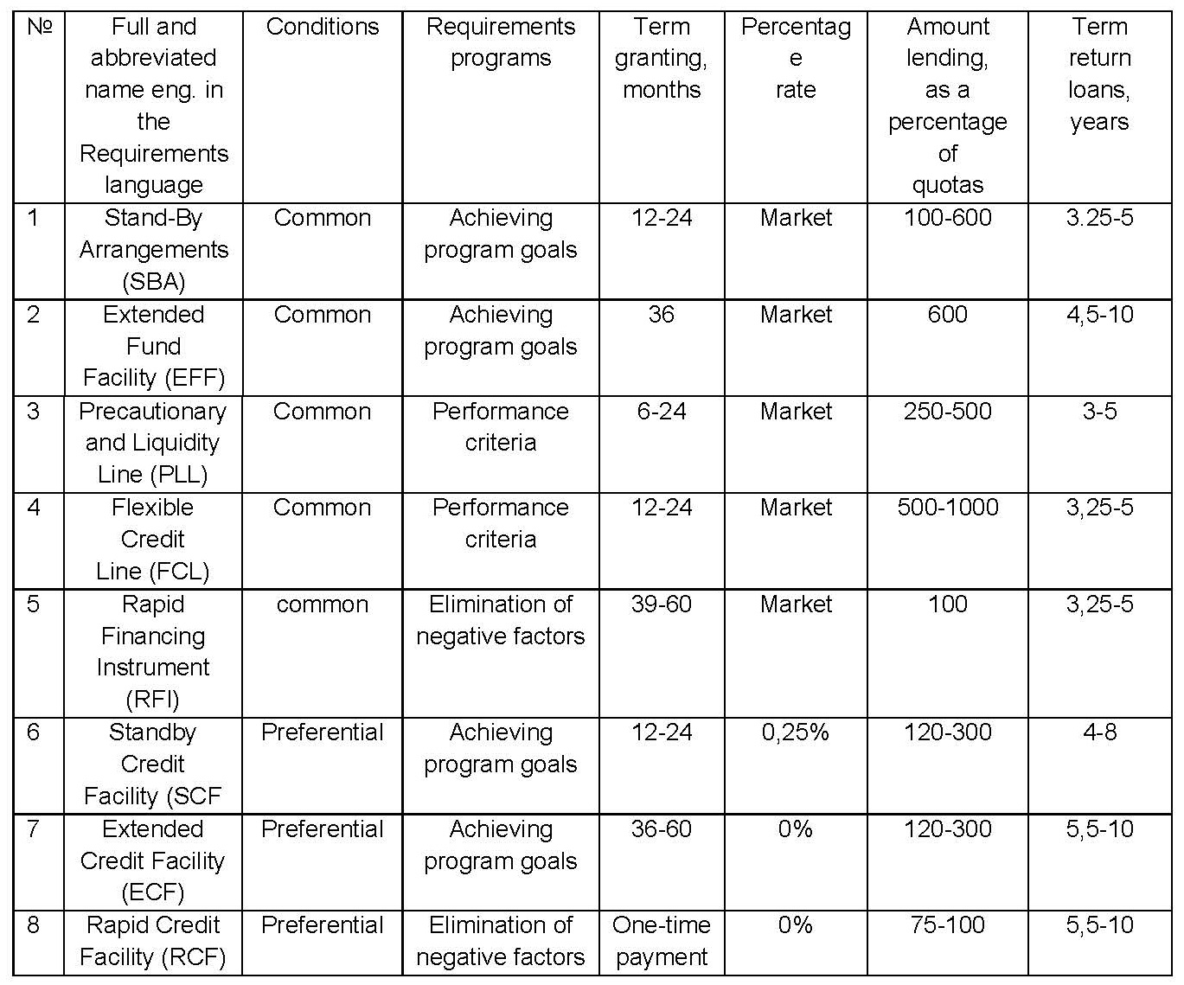

Of the remaining 14 per cent, agreements were reached under the Extended Credit Facility with Egypt (SDR 8.6 billion), Tunisia (SDR 2.1 billion), Sri Lanka (SDR 1.1 billion), Jordan (0, 5 billion SDRs), Bosnia and Herzegovina (0.4 billion SDRs), Cфte d'Ivoire (0.3 billion SDRs), Georgia (0.2 billion SDRs) and Moldova (0.1 billion SDRs) ).

The stand-by loan arrangement with Iraq (SDR 3.8 billion), Jamaica (SDR 1.2 billion) and Suriname (SDR 0.3 billion) accounted for 5 percent of the new arrangement.

The successive agreements on the lines of preventive support and liquidity with Morocco amounted to 2.5 billion SDRs, ie 3 percent of that remained [4].

The IMF's IMF policy is a whole set of instruments and mechanisms that are structured as specialized loan programs, and the criteria for approving a country-specific program are determined by a specific system. Nevertheless, it should be noted that the conditions under the program are variational in nature and depend on the results of bilateral agreements between the borrower region and the IMF, the essence of which may depend both on decisions made by the IMF management apparatus and on the existing geopolitical situation [5].

Analyzing the impact of the IMF's financial and credit activities on the global economy, it looks at the results of a program or instrument, as there is a wide variation both in the instruments and mechanisms and in the work with specific countries. Therefore, it is advisable not just a general overview of the programs, but specifically the results they have produced in different countries. In addition, it is advisable to compare the results of economic activity of the countries actively using the IMF.

 Stand-By Arrangements (SBA) programs were introduced by the IMF in 1952 and have since been a major lending tool both in terms of volume and frequency of use. These programs provide rapid access for Member States to the Fund's resources to facilitate economic reform and sustainable economic growth. IMF financial assistance under these programs was instrumental in overcoming the effects of the financial crises of the 1990s and 2000s.

Turkey has actively used IMF resources to adjust its balance of payments since 1984 and received loans for five stand-by programs totaling SDR 35.4 billion. Of particular importance for the economic recovery of the country were the last three programs in the early 2000s, which were able to overcome the effects of the financial and economic crisis and restore economic growth. IMF lending has also helped attract financial assistance from the World Bank and the EU. External financial assistance facilitated the implementation of important structural reforms in the export-oriented industries by the official bodies of the country, in particular, enabled large-scale privatization of light and manufacturing enterprises, reformed the labor market, secured dynamic development of the service sector, and stopped the large-scale economic outflow. The reforms have increased the competitiveness of Turkish goods, restored export volumes, increased productivity and reduced unemployment.

Turkey has experienced high volatility in GDP growth and inflation during 2006-2013. According to the IMF forecast, in 2014 GDP growth will decrease to 2.3%, inflation will be at 7.8%, and the balance of payments deficit will be at 6.3% [6].

Financial assistance in preventing Greece's default in 2010 played an important role. The Fund, together with sixteen EU countries, has developed a Ђ 110 billion financial assistance package. The stand-by program and extended lending totaling over SDR 50 billion has become a major part of this assistance package. In fact, through the stand-by program, the fund has unlocked EU financial assistance. At the same time, the implementation of the economic reform program, which included stringent demands for cuts in public spending, wage cuts, retirement, tax hikes, had negative social consequences for the Greek population and caused a wave of social discontent in the form of strikes, protests and riots. However, in 2014, the IMF reported positive results of financial support for reforms. For the first time since the crisis, in 2014, positive GDP growth is projected at 0.6%, the balance of payments surplus at 0.9%, and inflation at about 0% [6].

However, the implications of the financial assistance to Argentina are ambiguous.

Argentina's credit history since 1984 includes eight standby programs and two extended lending programs totaling SDR 38.6 billion. Argentina's economy suffered the greatest losses during the crisis that began in the late 1990s and lasted until the early 2000s. In 2001, Argentina declared a record default of $ 132 billion. In 2002, the crisis period ended and positive growth rates were restored. The main causes of the crisis in Argentina were the large budget expenditures, the pegging of the national currency to the US dollar and the granting of preferences to foreign investors, the imperfect tax system, corruption, the payment crisis, populist social policy, external factors that led to the deterioration of trading conditions.

Critics of the IMF policy point out that, in the case of Argentina, the fund's inconsistent policy has led to a defaulting country with a thriving economy. The IMF demanded that the government of Argentina implement a tight budgetary policy and provided financial assistance for reforms until 1998, after which it paused and resumed financing only after default.

Currently, Argentina has no debt to the IMF, the last lending program ended in 2006, and the fund has not been consulted since. The termination of consultations with the IMF has had a negative impact on Argentina's economy. Since 2006, there has been a high volatility of GDP growth rates, and in the last three years GDP growth rates have been steadily decreasing and, according to the IMF, will amount to 0.5% in 2014. Also in the last three years, Argentina has a balance of payments deficit, which the IMF forecasts in 2014 will be 0.5%. During 2006-2013, there has been an increase in inflation, which in 2006 and 2013 exceeded 10% [6].

Extended Fund Facility (EFF), introduced by the IMF in 1974 to provide medium- and long-term financial assistance to member countries, has been widely used in times of crisis. It is provided in order to settle the balance of payments in the event of a significant breach of solvency due to structural deficiencies in the economy or slowdown in economic development, increase in the negative balance of payments. Such a program was carried out for Ukraine, it envisaged a loan of USD 2.6 billion. USA. In total, Ukraine received SDR 1.193 billion (US $ 1.591 billion), which was intended to replenish the foreign exchange reserves of the National Bank of Ukraine. What helped stabilize the exchange rate gave the impetus for economic recovery in the early 2000s [7].

Flexible Credit Line (FCL). In order to prevent or mitigate the crisis, the Fund's financial assistance is provided through a flexible line of credit. Lending is granted exclusively to those countries that have stable macroeconomic conditions, effective monetary and financial policies and a high ability to implement it, a positive credit history of interaction with the Fund. The IMF has developed criteria for borrowing countries.

A flexible line of credit can be issued immediately after being approved, or postponed for some time - to counter future calls.

To date, only three countries have used this financial instrument: Colombia, Mexico and Poland. It should be noted that none of these countries received the funds, but an open flexible line of credit is a strong guarantee of the solvency of these countries in the conditions of high probability of realization of threats to financial stability.

The Precautionaryand Liquidity Line (PLL) is used for countries with stable macroeconomic conditions that need to compensate for insufficient liquidity in the face of temporary threats, access to a preventive credit line. To be able to access the Fund's resources, the borrowing country must meet the standards and criteria set. In addition, the Fund's experts evaluate the external position and access to foreign markets, budgetary policy, monetary policy, and macroeconomic indicators.

The effectiveness of this line is determined by comparing the terms of the initial credit and the annual monitoring of the factors being eliminated. Only Macedonia and Morocco received funding under this line. For both countries, it has had a positive result, but despite this cooperation with the Fund requires further implementation by the country's official bodies of structural reforms and the creation of security buffers.

Rapid Financing Instrument (RFI) introduced by the IMF in 2011 to replace two emergency financial programs - Emergency Natural Disaster Assistance (ENDA) and Emergency Disaster Relief Program (ENDA) Emergency Post-Conflict Assistance (EPCA).

 It should be noted that such assistance is always relevant. Thus, in 2007, the Fund provided 34 times, in 2010 - 13 times, and since 2001, emergency financial assistance has been provided not only to low-income countries, but also to the Incas countries emerging: Iraq (2004), Lebanon ( 2007, 2008), Pakistan (2010), Sri Lanka (2005), Maldives (2005) and others.

Speaking of financial programs with preferential lending to a group of low-income countries (gross national income less than $ 1,500 per capita). On the plus side, they are generally granted at zero or lower than the market rate, with a grace period. The Fund shall review interest rates every two years.

The IMF has identified two main channels of influence on the financial stability of low-income countries: in the short-term, the financing of the fund contributes to the mitigation of liquidity shocks, and in the long-term, promotes macroeconomic stability [8]. For these purposes, a set of special tools are used, which include:

- Standby Credit Facility (SCF) for low-income countries. The stand-by credit facility is designed for low-income countries to adjust their balance of payments in the short term. It aims at restoring stable macroeconomic conditions to ensure sustainable growth and poverty reduction. It is also used to eliminate balance of payments risks. It is also a catalyst for receiving external assistance from other donors;

- Extended Credit Facility (ECF) for low-income countries. Such a lending instrument aims to provide low-income countries with the necessary financing to balance their payments. It is intended to facilitate the implementation of economic programs aimed at creating stable macroeconomic conditions for poverty reduction and economic development. Is a catalyst for receiving external assistance from other donors;

- Rapid Credi tFacility (RCF) for low-income countries. This type of lending allows you to quickly access emergency fund resources. It is provided to regulate the balance of payments and in the event of natural disasters, crises, political conflicts with economic consequences. Promotes lending to other donors.

According to some estimates, there is a problem of inadequacy of requirements of international financial organizations to the realities of economic relations in different countries. For the most part, this problem is due to the Fund's use of templates that apply to other countries in the world, including Latin America. Also, the changes in the development model of the recipient countries of the IMF assistance are not taken into account.

A pressing problem is the indirect influence on the activities of the current government of the state. As an example, the expectation of IMF funding at the macroeconomic level reduces government accountability for its policies.

The very fact of expecting cheap loans from the IMF distorts the macroeconomic environment, adversely affecting business activity. As a result, there is a decline in activity in the banking sector, which entails a slowdown in the real economy.

**Conclusions (and suggestions).** To date, the results of the IMF's activity are both positive changes in the economies of the assisted countries and negative ones, such as the further increase in low-income countries' debt, or the implementation of post-Soviet programs. Therefore, the impact of the IMF on the world economy cannot be positively or unequivocally negative.

**REFERENCES:**

1. *Офіційний веб-сайт Міжнародного валютного фонду*. Вилучено з: http://www.imf.org.
2. Герчикова,  І.  М.  (2011) *Міжнародні  економічні  організації:  регулювання світогосподарських  зв'язків  та  підприємницької  діяльності:  навч.  посібник*. К.: АТ «'Консалтбанкір».
3. Эбке, В.  Ф.  (2007).  *Международное  валютное  право.*  М.:  Междунар. отношения.
4. *Годовой отчет МВФ 2017 Содействие всеобъемлющему росту IMF*. Вилучено з:  http://www.imf.org/external/pubs/ft/ar/2017/ eng/pdfs/AR17-RUS.pdf.
5. *Світовий  економічний  прогноз  World  Economic  Outlook*. Вилучено з: http://www.imf.org/external/ns/cs.aspxid=29.
6. *International  Monetary  Fund:  From  Wikipedia,  the  free encyclopedia*.  Вилучено з:  https://en.wikipedia.org/wiki.
7. *Review of Facilitiesfor Low-Income Countrie*s (2012) // International Monetary Fund.
8. Stiglitz, J.E., Norton,  W.W. (2012). *Globalization and Its Discontents*.  New-York.

**ВПЛИВ МІЖНАРОДНОГО ВАЛЮТНОГО ФОНДУ НА ПРОЦЕСИ СВІТОВОЇ ГЛОБАЛІЗАЦІЇ  
  
АМЕЛЬНИЦЬКА Марія Іванівна,**здобувач вищої освіти факультету економіки та менеджменту  
Донецький національний технічний університет  
УКРАЇНА  
 **НАУКОВИЙ КЕРІВНИК:  
  
Придатько Елла Миколаївна**, к.е.н., доцент, доцент кафедри управління і фінансово-економічної безпеки  
Донецький національний технічний університет  
УКРАЇНА **Анотація.**У статті надано аналіз діяльності Міжнародного Валютного Фонду з позиції світової глобалізації, визначено можливі напрями впливу функціонування МВФ на регулювання процесів глобалізації. Охарактеризовано вплив фінансово-кредитної діяльності МВФ на міжнародну економіку та сучасної політики МВФ щодо кредитування.  Здійснено аналіз використання фінансової допомоги МВФ країнами в їх економічній діяльності.  
  
***Ключові слова:****Міжнародний Валютний Фонд; кредитування; фінансово-кредитна політика, світова економіка; фінансово-кредитні механізми*