УДК 622. 834
V.K. KOSTENKO (Professor Doctor of Technical Science), E.L. ZAVYALOVA (Associate Professor Candidate of Technical Science), H. W. SHEVCHENKO (Candidate) Donetsk National Technical University, E.G. Zavyalova (Candidate) Moscow National University
elenazavialova@rambler.ru

PREVENTION OF COAL SELF-HEATING IN ZONES OF GEOLOGICAL DISTURBANCES

The new methods of the endogenous fire prevention in the conditions of flat, medium and steep pitch on basis of classification of the methods of the prevention of self-heating and self-ignition of coal at the excavations opening of geological disturbances were developed.
the faulted area, spontaneous combustion and coal self-heating sites, fire hazardous zone, faulted seam structure, effusive process, prevention of self-combustion fires, antipyrogenes.

Problem and its communication with the scientific and real-world problems.
The underground fires are the most dangerous type of the underground accidents which can significantly have an influence on the normal operating mode of mines and lead to serious economic and social consequences. They cause serious disturbances of the technological process which leads to significant losses for the adventure in the form of losses from reduction of coal production, the fire damages and the costs of underground fire extinguishing and liquidation of their consequences. Precedents of self-heating of coal in certain conditions occur fairly often. They constitute a significant threat of the industrial safety for miners. Besides, large quantity of solid, liquid and gaseous substances form at slow coal oxidation produces which pollutes the environment, so the effective prevention of coal self-heating is also a social problem which allows improving ecological conditions.
The analysis of scientific researches and publications. In recent years, in increasing frequency places of self-heating and self-ignition of coal are found in the places of crossing with development heading of zones of geological disturbances of layers.
As an example, there were 16 cases of coal self-heating in the development heading of the western wing of coal layer - m₃ at the "Zasyadko Mine" in the period from 1998 to 2001 years. The timely liquidation of the places of self-heating has allowed preventing the emergence of endogenous fires. Similar cases took place on mines "Olhovatskaya" "Ordzhonikidzeugol", "Privolnyanskaya", G.G. Kapustina "Lisichanskugol" and others, however, the fires were not prevented in these mines as a result of no acceptance of steps on liquidation of the places of self-heating and self-ignition of coal that has led to the significant losses.
In such conditions, the prevention of coal self-heating in the excavations which crossed of zone of geological disturbances (ZGD) is an actual industrial problem.
The structure of coal layer in places of crossing with the development headings of geological disturbances is qualitatively different from layer structure on the virgin coal has been established by authors. The difference in ZGD is the presence at an affected zone of the excavations of the dense system of chaotic tectonic microcracks with opening width less than free length of gas molecules (10⁻⁷- 10⁻¹⁰ m) that surrounds the macrocracks [1, 2]. The features of layer structure determine the passing of effusive processes in the crack cavities which is accompanied by separation of gas mixture into the rectangular components. Flammable zones are formed in the places of crossing with the development headings of geological disturbances it causes of the formation of the areas with heightened oxygen content in the macrocracks.
Based on the structural features of damaged rock mass and gas dynamics in fractured zone hypothesis has theoretically proved about the initiating effect of geomechanical and thermodynamic (particularly effusive) processes in the parallel influence at the coal of chemical and biogeochemical factors that lead to self-heating and self-ignition of coal. This hypothesis has confirmed in practice [1, 2] and was used to develop the classification of the methods to prevent and liquidation of places self-heating and self-ignition of coal [1, 3] at the intersections of the ZGD with development headings (Table 1). This classification represents a tool that allows not only classifying the known preventive methods of the endogenous fires quenching but also modernizing and developing the new methods.
The essence of the classification approach is to consider aggregate methods and levers to the elements of forming flammable areas at the excavations that consists of a distended coal, a rock, moisture and the gas mixture.
The method, tactics, location, tools and time of influence are chosen depending on the accepted object. Thus, the problem is posed to develop a new method to prevent self-heating and coal self-ignition in mines or to upgrade the known method.
Table 1
The classification of the methods of prevention the coal self-ignition in the places of crossing of ZGD with development headings.
Graded criterion | The subject of preventive action
The object | Coal |  |  | Stone |  |  |  | Air |  |  | Methane |  |  |  | Water
The method of influence on the object | Reduction of cracked emptiness | Decrease of the diffuse layer | Changing the chemical properties | Treatment with antioxidants |  | Dilution of pore solutions | Reduction of oxygen access | Changing of gas composition | Control of consumption and pressure | Changing of the methods of motion | Decontamination of the massif |  | Control of gas recovery | Control with motion in the cavities | Control of filtration | Changing of the chemical properties | Changing phase state
The tactics | Distantly |  |  |  |  |  |  |  | Direct action
The place of the realization | Coal layer |  |  |  | Bearing strata |  |  |  | The support of excavation
The lever | Gas |  |  |  | Liquid |  |  |  | Solid |  |  | The combinations (foams, suspensions, aerosols)
The rate of the influence | Short-term |  |  |  | Periodical |  |  |  |  |  |  | Long-term

Target setting. Acceleration of coal self-heating in the places of crossing of the ZGD with the development headings was established to be caused by the isothermal effusive separation of gas mixtures and by the appearance of areas with heightened oxygen content in a system of the macro- and microcracks. The main task in the developing new methods of preventing coal self-ignition at the excavations was braking of effusive processes by restricting access of air oxygen to coal.
Account of material and results. The solution of this problem is methods of the prevention of coal self-heating in zones of geological disturbances. These methods were developed at the Donetsk National Technical University with the Environmental Activity Faculty. First of them consists: the suppression of effusive processes through the usage of gas separation membranes [1, 4] and second - reduce chemical activity of coal with the help of using long-acting antipirogene [1, 5, 6].
The choice of the method should be made for reasons of economic efficiency. If the ZGD width is small (а ≤1 m) and a compressed air magistral is available, so it is advisable to install the gas separation unit (Figure 1).

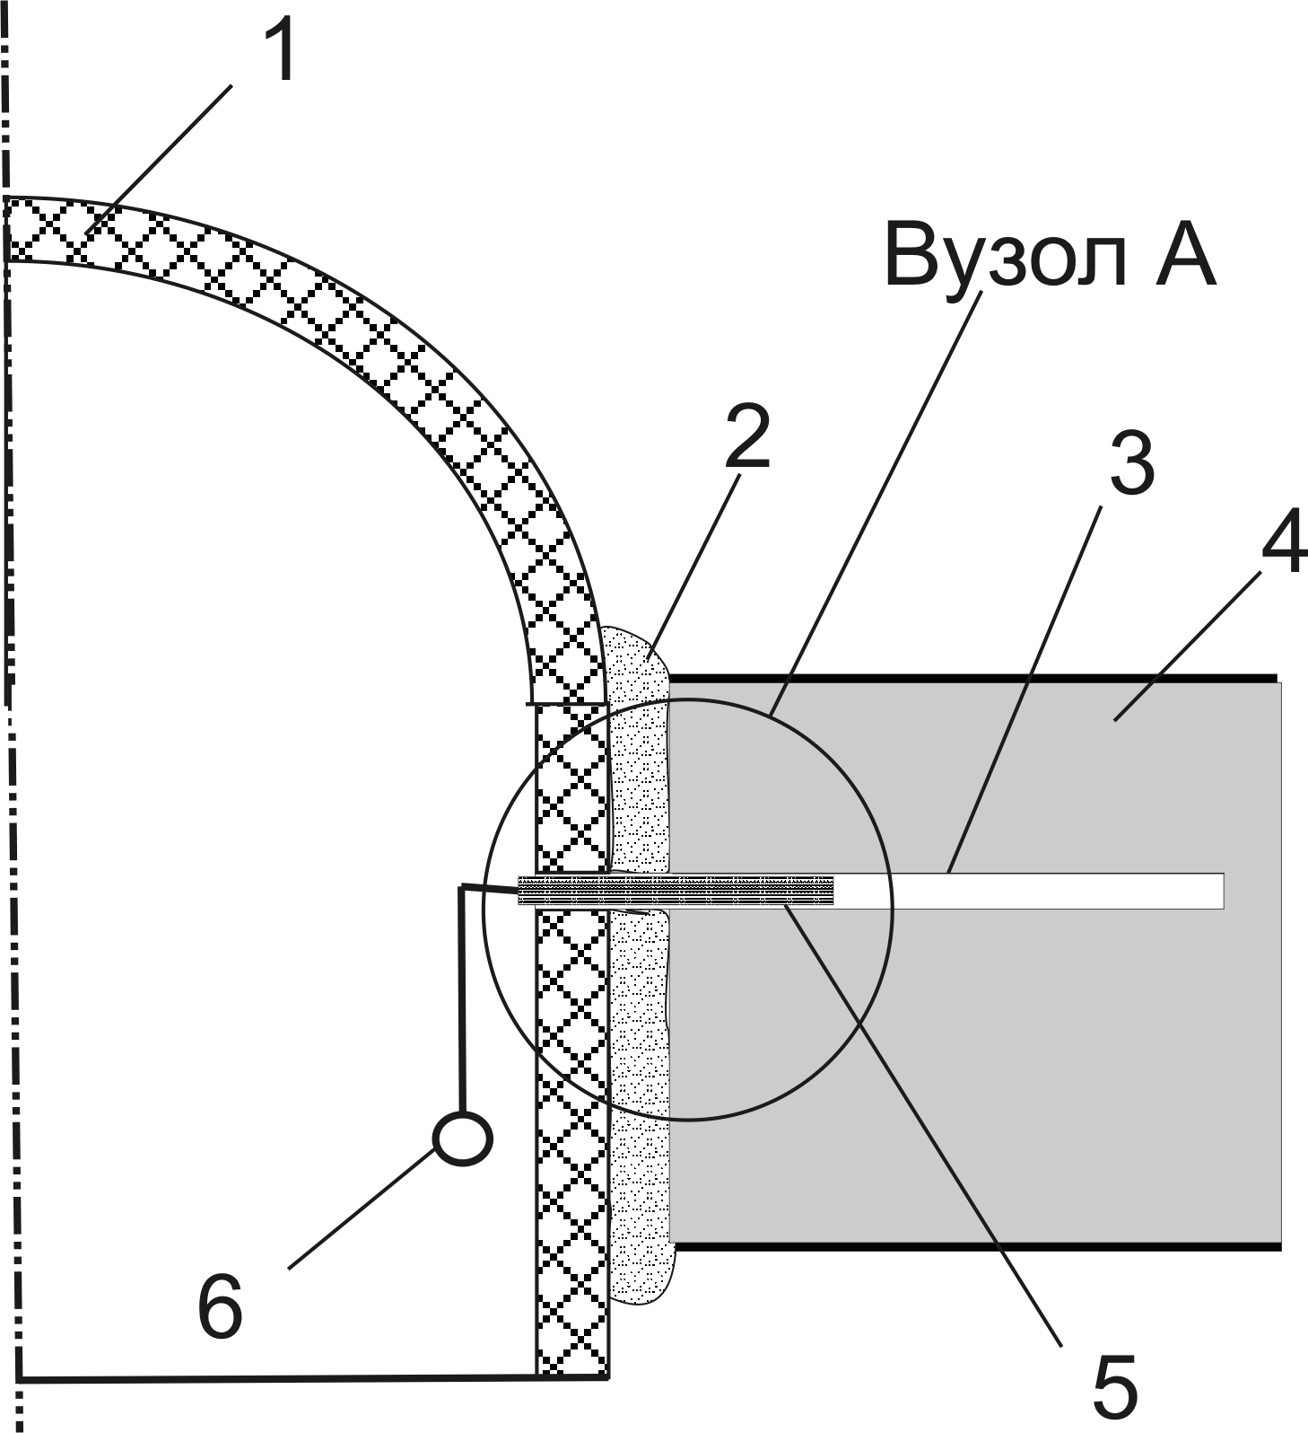
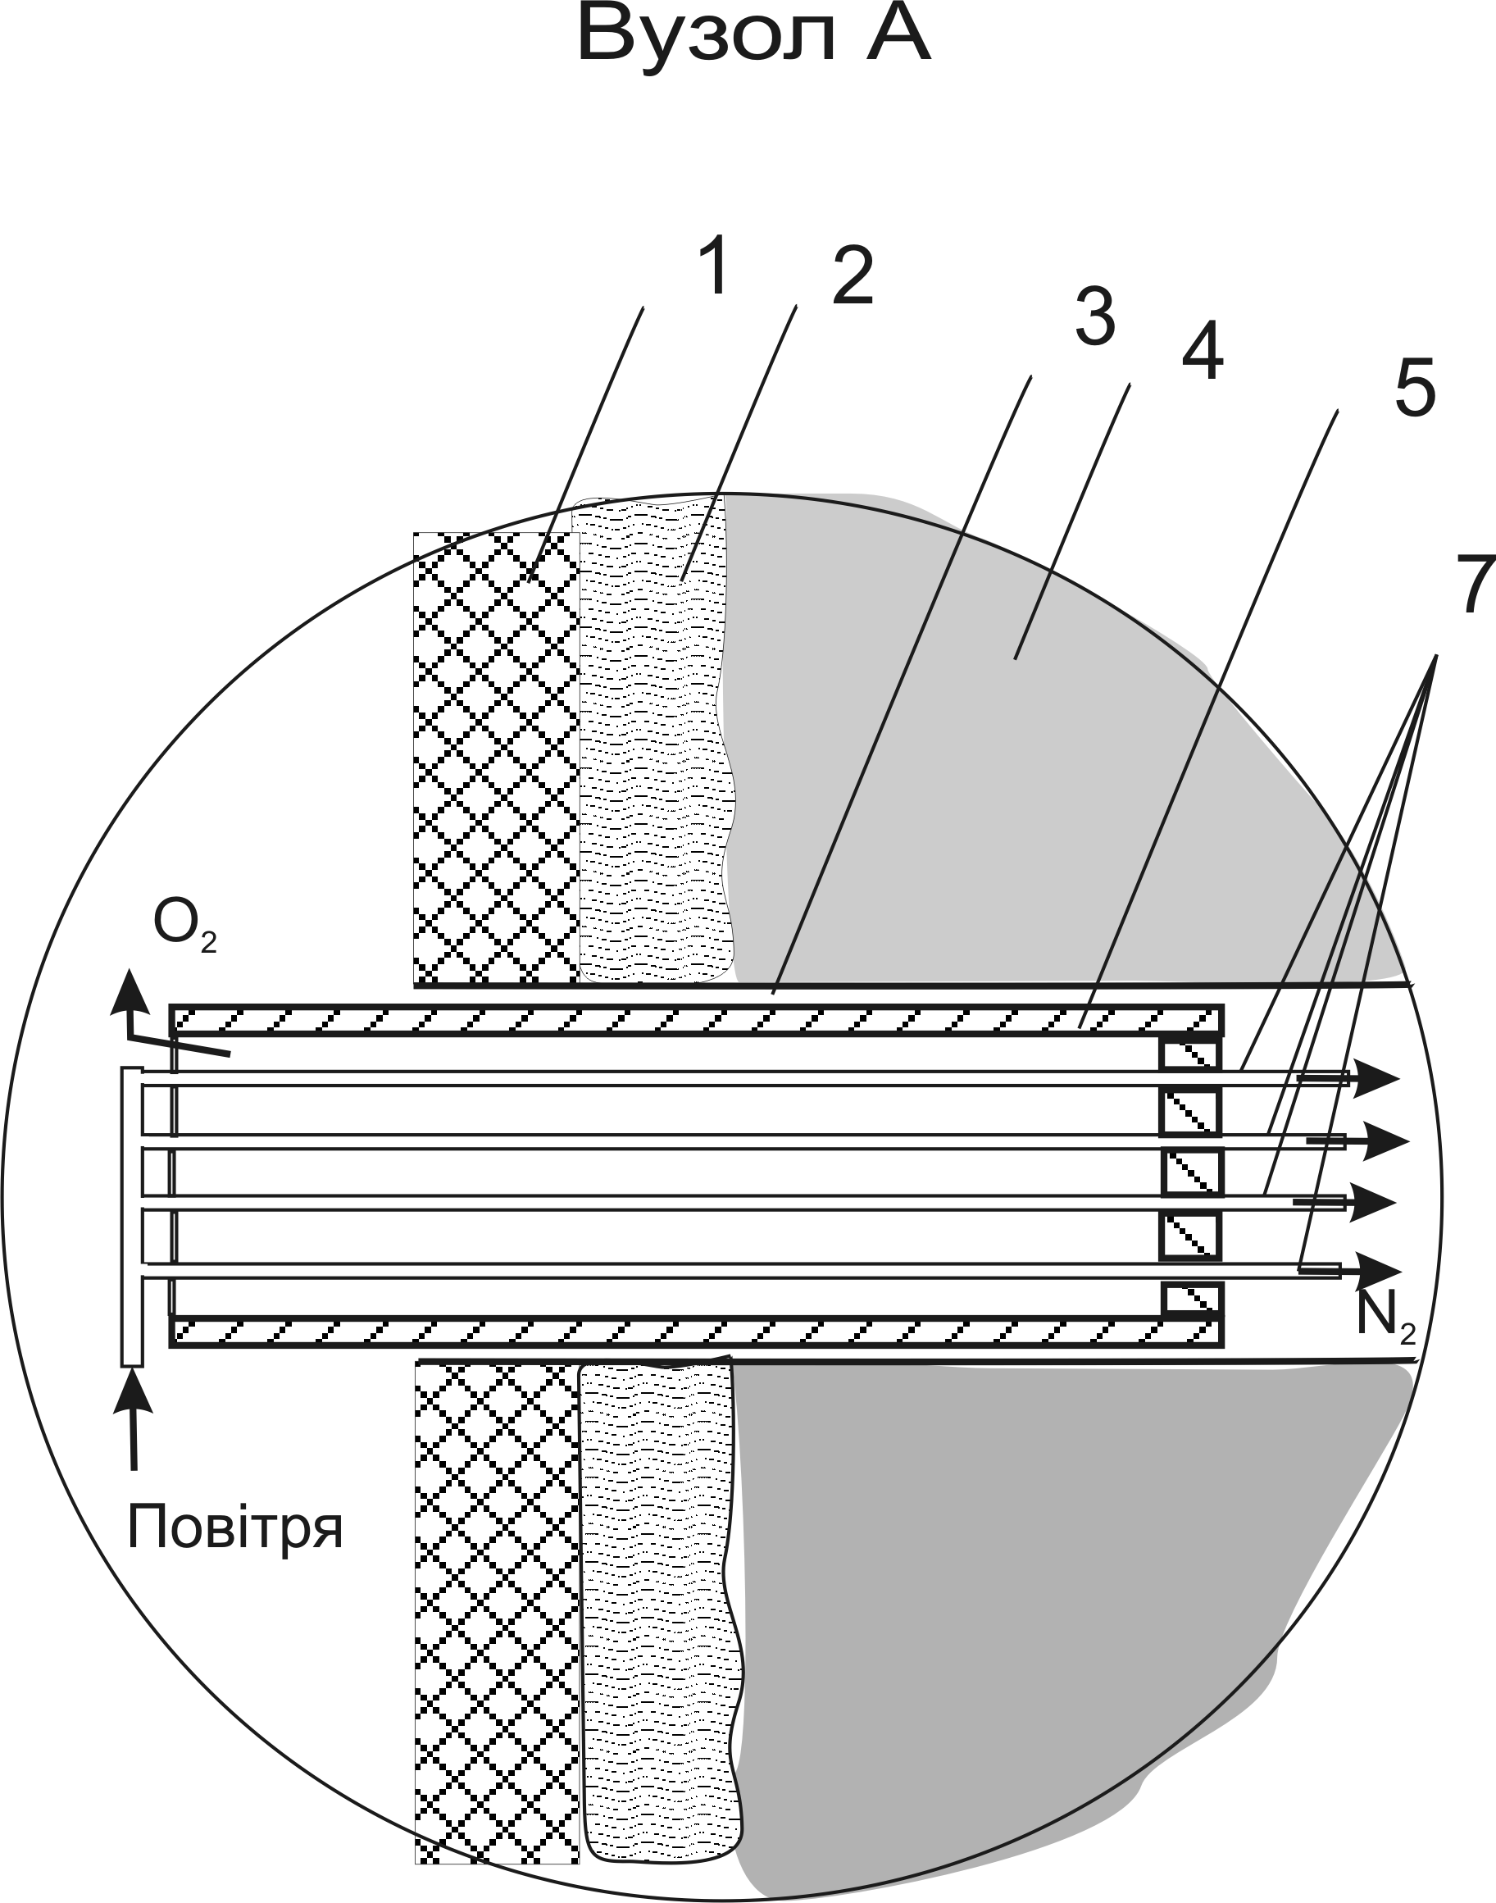
The unit A
The unit A

Figure 1. The method of the prevention of coal self-heating in the underground excavations: 1 – the support of excavation; 2 – the pliable insulating refractory material; 3 – the borehole; 4 – the coal layer; 5 - the gas separation unit; 6 – the compressed air magistral; 7 – the membrane unit.

The method of prevention of coal self-heating in the underground excavations is implemented as follows. When the development headings cross of ZGD of coal layer 4, the support is erected 1 and the space behind the support is filled with pliable insulating refractory material 2. The boreholes 3 are drilled into the roadway wall to the depth of 3 m. The gas separation unit 5 is inserted into the borehole and this unit is connected to the compressed air magistral 6.
Compressed air is supplied from the magistral 6 to the gas separation unit 5. Air oxygen penetrates through the fiber walls; nitrogen passes through the capillaries and emerges from the other side of the membrane unit 7 in the borehole 3 and further along the crack to coal layer 4. The gas separation unit provides 95% purity nitrogen gas with pressure of 0.6 MPa. Thus, the conditions are not formed for the appearance of high oxygen content zones in fractured coal areas and, consequently, the centers of coal self-heating.
Air supply is carried out periodically at intervals which does not exceed incubation period of coal self-ignition, which is determined according to [6]. Quantity of applied nitrogen is calculated by the formula:
V_{nitrogen}=4K_{ce}·m·u_{l}·b_{d},
where:
К_{ce}- the average coefficient of cracked emptiness, m;
m - the seam thickness in the ZGD, m;
u_{l} - the value of the lateral wall displacement of the excavation, m;
b_{d} - the width of the ZGD, m.
If а>1 m, it is more cost-effective to use of long-acting antipirogene (Figure 2).

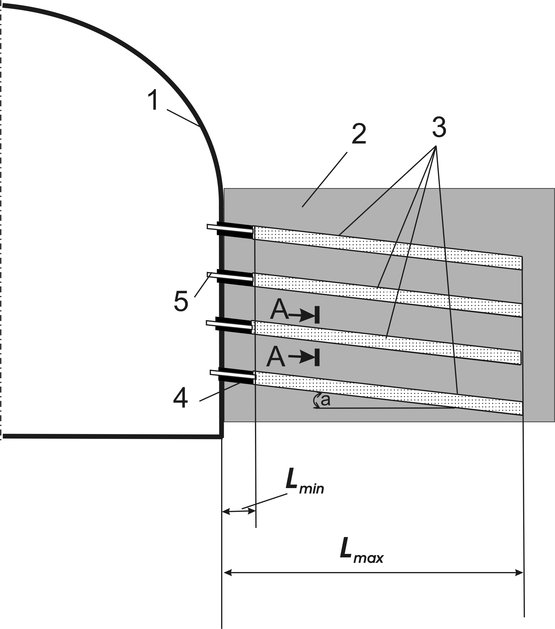
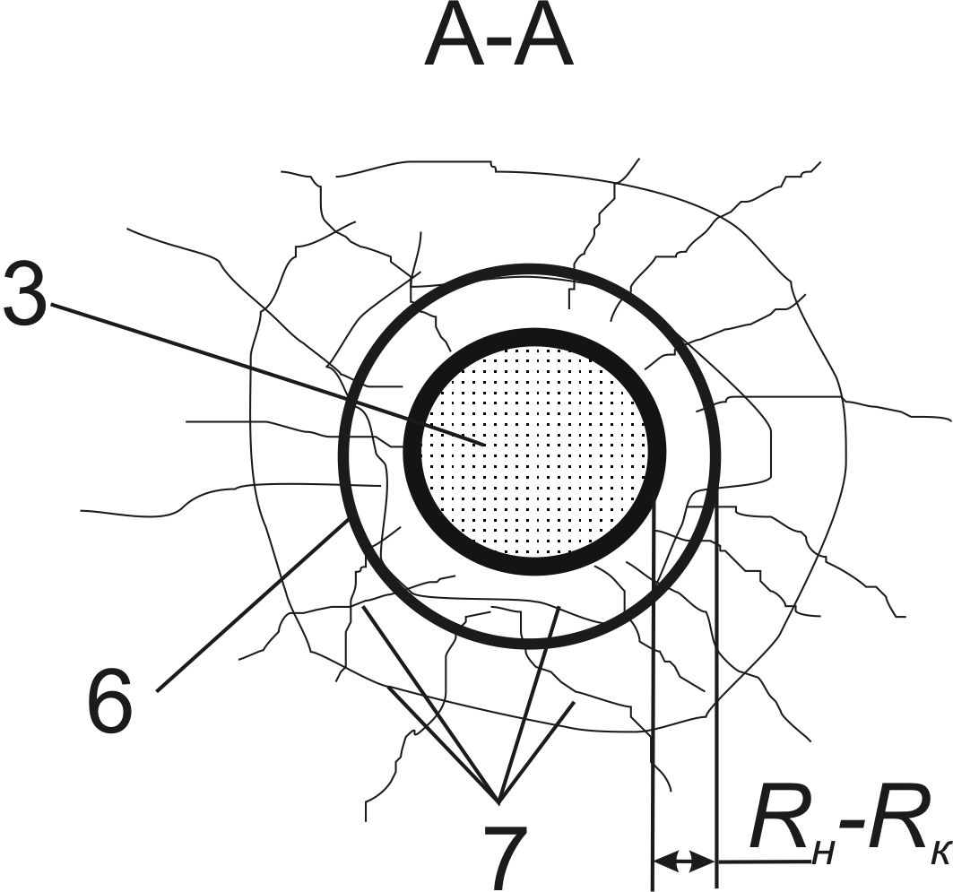

Figure 2. The method of the prevention of coal self-heating in the coal layer: 1- the support of excavation; 2 – coal layer; 3 – the filled with antipirogene boreholes; 4 – the clay plug; 5 – the tube; 6 – the contour of the borehole; 7 – the cracks in the coal layer; R_{i}-R_{f} – the difference between initial and final radius of the borehole.

The boreholes are drilled on the coal layer; the length of boreholes is 2.5 m. The length of the boreholes equals to the largest distance from the roadway wall, L_{mах}. Boreholes are drilled on-the-miter α=5…10⁰ with a gradient from the mouth to coal-face. The vertical and horizontal distances between the boreholes are selected in the range 0.4...0.5 m.
The mixture consists of atomizated coal and ferrous metal to be prepared in the drift. The rubble can be used as the atomizated coal. It formes by drilling boreholes. The degreased chips of CT-3 steel can be used as ferrous metal, which is a refuse at the repair and mechanical workshops.
The ingredient fragments must be no larger than 10...20 mm. Ratio of coal to metal is as follows: coal 15%, metal 85%. The mixture of mass 9.5 kg is prepared to fill one borehole, which consists of 1.4 kg of atomizated coal and 8.1 kg of shredded metal chips. Solution of sodium chloride is also prepared at the amount of 1.7 liters per borehole (0.5 kg of salt is dissolved in 1.5 l of water).
The ready mixture is fill up of the borehole and the borehole is filled at the site from the coal-face up to 0.5 m from the mouth. The rest of the part of borehole (from the mouth to mixture) is covered by the clay plug with the tube. The length of plug is equal to the minimum distance, L_{mіn}, where the sources of coal self-heating have been reported. A sodium chloride solution is delivered in the filled with a mixture borehole.
Chlorine is formed during the electrolysis process of sodium chloride and then it interacts with the coal surface and neutralizing the active centers of coal self-heating.
The deformation of the borehole occurs under the influence of rock pressure, its initial perimeter is being significantly reduced. Borehole radius decreases from the initial size, R_{i}, to the final size, R_{f}, (see Figure 2). The cracks appear around the borehole. At the same time, fresh coal surfaces predisposed to self-heating also appear.
The shift of coal and metal particles in the antipetalous mixture occurs due to the deformation of side of hole. The new galvanic couples are appeared and chlorine is released, which washes of fresh coal surfaces neutralizing the active centers. The process lasts continuously, that allow avoiding the negative influence of rock pressure and providing the reliable and effective prevention of endogenous fires when a new crack occurs under the influence of rock pressure.
However, the application of this technology causes some difficulties in case of flat and steep pitch. The main obstacle arises when the boreholes are being filled with antipirogene mixture.
This problem can be solved using the application of the ‘antipirogene chucks’, which represent antipirogene mixture. This mixture is placed in a non-watertight shell. The shell could be represented by ordinary hessian. This step allows not only keeping antipirogene mixture in the borehole, but also retaining the electrolyte solution that is served separately through the metal tube, it hinders electrolyte solution draining by gravity to the bottom of the borehole. For the convenience of the filling the borehole the ‘antipirogene chucks’ should not exceed 0.5 m in length and 0.04 m in diameter, and the filling should not be dense.
Taking into account the above the following technology of the endogenous fire prevention in ZGD in flat and steep pitch layers could be suggested (Figure 3).
The area contour of excavation 1, which intersects coal layer 2, is isolated with elastic flexible material 3, which can be represented with the vent or the conveyer belt. The 2.5 m boreholes 4 are drilled in coal layer. The borehole length equals to the largest distance from the working wall, L_{mах}, where the appearance of self-heating and coal self-ignition pockets is possible. The vertical and horizontal distances between the boreholes are chosen in the range of 0.4...0.5 m.
The ‘antipirogene chucks’ 5 are prepared preliminarily. The ingredient fragments should be no larger than 10...20 mm. The mixture of mass 9.5 kg is prepared to fill one borehole, which consists of 1.4 kg of atomizated coal and 8.1 kg of shredded metal chips. This mixture is divided into four equal parts to fill the ‘antipirogene chucks’ shells. Solution of sodium chloride is also prepared at the amount of 1.7 liters per borehole (0.5 kg of salt is dissolved in 1.5 l of water).
The stainless steel tube 6 is placed in the drilled borehole, and then ‘antipirogene chucks’ 5 are laid. The rest of the borehole area up to the mouth is closed with the clay plug 7. The tube length is equal to the minimum distance, L_{mіn}, where the sources of coal self-heating have been reported. Sodium chloride solution is delivered in the filled with a mixture borehole.

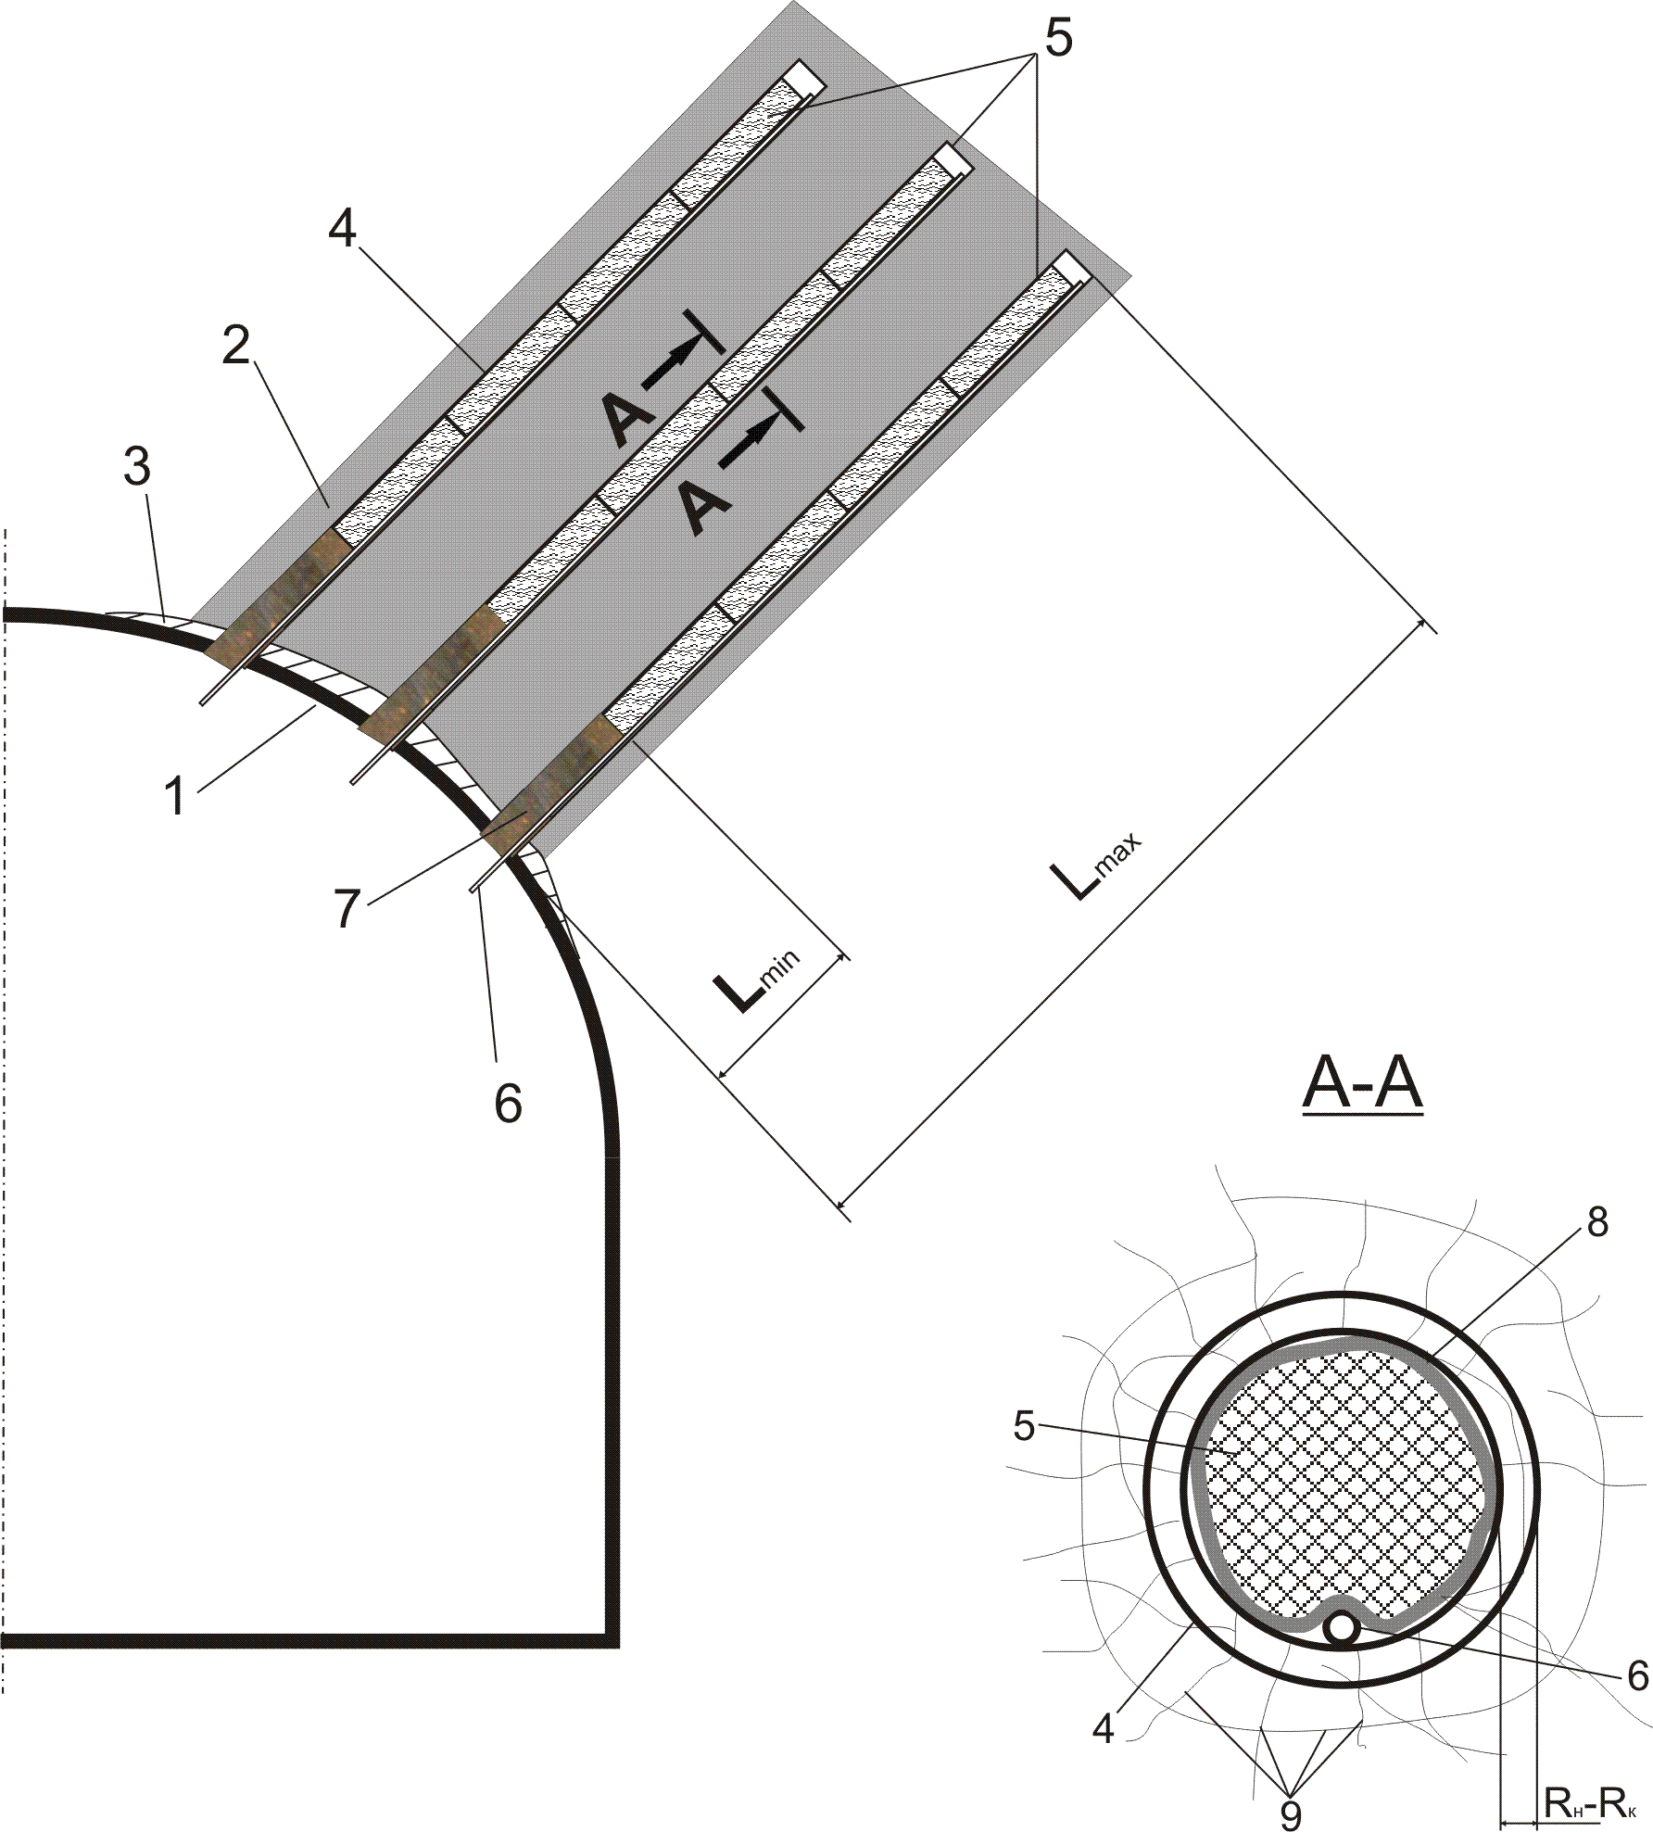
Figure 3. The method of the prevention of coal self-heating in flat and steep pitch coal layers: 1 – the support of excavation; 2 – the coal layer; 3 – the flashing; 4 – the boreholes; 5 – the ‘antipirogene chucks’, 6 – the tube; 7 – the clay plug; 8 – the ‘antipirogene chucks’ shell; 9 – the cracks in the coal layer; R_{i}-R_{f} – the difference between initial and final radius of the borehole.

Conclusions. Thus, the developed methods of the coal self-heating prevention, which crosses of the excavations with ZGD foresee the usage of cheap non-deficient materials that do not contain dangerous or harmful ingredients. Intermediate products are formed in a slight amount and these products instantly react with coal not segregating out in the excavations.
The obtained theoretical results allow proving the following technological parameters:
- the borehole length is l_{b}=L_{max};
- the depth of stem is l_{t}= L_{min};
- an angle of borehole slope α= 5…10^{о}. This is necessary in case of long-acting antipirogene applying for denser borehole filling with electrolyte. If the tilted borehole drilling is impossible, the gas separation unit should be used;
- the maximum distance between the boreholes in ZGD with the width greater than а_{k}. The preventive treatment of these disorders should be provided, so that there are no untreated areas with dimensions more than а_{k}. Consequently, the maximum distance between the boreholes is recommended to be b_{b}≤а_{k}, taking into account the guaranteed processing of all ZGD;
- the total borehole amount is n= а/b_{b}.

REFERENCES

1. Предупреждение и тушение подземных эндогенных пожаров в труднодоступных местах/ [Костенко В.К., Булгаков Ю.Ф., Подкопаев С.В. и др.]; под ред. В.К. Костенко. – Донецк: Изд-во «Ноулидж» (донецкое отделение), 2010. – 253 с.
2. Костенко В.К. Особенности самонагревания угля вблизи контура горной выработки в зонах геологических нарушений/ В.К.Костенко, Е.Л.Завьялова// Форум гірників – 2005: матеріали міжнарод. конф., 12-14 жовт. 2005 р. Т.3.–Дніпропетровськ, 2005. – С. 40 – 47.
3. Костенко В.К. Классификация способов подавления самонагревания угля в пересекаемых подготовительными выработками зонах геологических нарушений пластов / В.К.Костенко, Е.Л.Завьялова// Науковий вісник УкрНДІПБ. – 2006. – №2(14). – С. 34 – 39.
4. Пат. на винахід № 85499 Україна, МПК Е21F 5/00.Спосіб попередження самонагрівання вугілля у підземних гірничих виробках/ В.К.Костенко, О.Л.Зав’ялова; заявник і власник ДонНТУ. – №200602380; заявл.03.03.2006; опубл. 26.01.2009, Бюл. №2.
5. Пат. на винахід №83925 Україна, МПК Е21F 5/00. Спосіб попередження самонагрівання вугілля у пласті/ В.К.Костенко, О.Л.Зав’ялова, О.Г.Зав’ялова; заявник і власник ДонНТУ. – №200612444; заявл. 27.11.2006; опубл. 26.08. 2008, Бюл. №16.
6. Завьялова Е.Л. Технология предотвращения самонагревания угля в зонах геологических нарушений пластов/ Е.Л.Завьялова// Науковий вісник УкрНДІПБ. – 2007. – №2(16).– С. 28–34.

Поступила в редакцию 08.04.2011 Рецензент: Булгаков Ю.Ф.

КОСТЕНКО В.К. (д. техн. наук, проф.), ЗАВЬЯЛОВА Е.Л. (канд. техн. наук, доц.), ШЕВЧЕНКО Е.В. (аспирант) Донецкий национальный технический университет, ЗАВЬЯЛОВА Е.Г. (аспирант) Московский государственній университет
ПРОФИЛАКТИКА САМОНАГРЕВАНИЯ УГЛЯ В ЗОНАХ
ГЕОЛОГИЧЕСКИХ НАРУШЕНИЙ
Разработаны новые способы профилактики эндогенных пожаров в условиях пологого, наклонного и крутого падения пластов на основе классификации способов предотвращения самонагревания и самовозгорания угля в горных выработках, вскрывающих геологические нарушения.
зона геологического нарушения, очаги самовозгорания и самонагревания угля, пожароопасная зона, эффузивные процессы, способы профилактики эндогенных пожаров; антипироген.

КОСТЕНКО В.К. (д. техн. наук, проф.), ЗАВ'ЯЛОВА О.Л. (канд. техн. наук, с.н.с.), ШЕВЧЕНКО О.В. (аспірант) Донецький національний технічний університет, ЗАВ'ЯЛОВА О.Г. (аспірант) Московський державний університет
ПРОФИЛАКТИКА САМОНАГРІВАННЯ ВУГІЛЛЯ У ЗОНАХ ГЕОЛОГІЧНИХ ПОРУШЕНЬ
Розроблено нові способи профілактики ендогенних пожеж в умовах пологого, похилого і крутого падіння пластів на основі класифікації способів запобігання самонагріванню та самозайманню вугілля в гірничих виробках,що розкривають геологічні порушення.
зона геологічного порушення, осередки самозаймання і самонагрівання вугілля, пожежонебезпечна зона, ефузивні процеси, способи профілактики ендогенних пожеж, антипіроген.

