SUPERSENSORY COMPUTER: IDEA AND ARCHITECTURE

R. Varzar, A. Anopriyenko
Donetsk National Technical University, Computer Sciences and Technologies faculty, Ukraine, Donetsk, 83001, str. Artema, 58, e-mail: vrxfile@mail.ru
Donetsk National Technical University, Computer Sciences and Technologies faculty, Ukraine, Donetsk, 83001, str. Artema, 58,e-mail: anoprien@cs.dgtu.donetsk.ua

Abstract: Supersensory computer is intelligent mobile device with many various tiny sensors for complex multipurpose monitoring of main parameters of the environment. Experimental model of supersensory computer measures the following parameters: temperature, relative humidity, atmospheric pressure, illuminance, mechanical vibrations, acoustic noise, magnetic field, ionising radiation and electromagnetic radiation.

Introduction

Today, one of the most important problems of the modern world is the pollution of the environment. The major polluting factors are chemical, biological pollution, electromagnetic fields and ionizing radiation, vibration and noise, the impact on weather and climate. Thus, there is a need to develop and create a system that measures the intensity of these factors, followed by further analysis and prediction of their influence on the human environment and the planet. To achieve this task, it is important to perform the following steps:
- development of supersensory computer;
- development of intelligent supersensory computer network;
- software development for analyzing and forecasting data.
This report briefly describes the hardware architecture of supersensory computer.

Main definitions

Supersensory computer - is an intelligent sensor device, which includes a large number of tiny sensors, microprocessor, memory, and communication. Intelligent of supersensory computer is available in the microprocessor programmed by special algorithms to analyze the measured parameters.
Sensor network - a distributed adaptive wireless network of small intelligent sensor devices. Appointment of intelligent sensor networks is collecting, processing and transmission of information with high demands for autonomy, reliability, scalability, and distributivity of network.

Hardware architecture

Universality, the presence of a different digital interfaces and ADC allows connecting analog and digital sensors, which measure various parameters of the environment and have different accuracy and precision of measurements. The modular design (figure 1) of the device makes it easy to replace the sensors and modules.
Supersensory computer has multiple interfaces for data exchange with other devices and the Web-server: USB, serial port, Bluetooth, GSM modem, Wi-Fi. It also contains a built-in non-volatile memory, real time clock, and allows connecting external storage devices such as memory cards. It powered by the built-in lithium-ion or lithium-polymer battery, an AC adapter or a port USB.
Supersensory computer (figure 1) consists of the following modules (using the simple modular architecture that allows quickly replace any of the modules or sensors): MicroController Unit (MCU), Analog-to-Digital Converter (ADC), Communication Module (CM), Memory Module (MM), Power Module (PM), Real Time Clock (RTC), Navigation Module (NM), Sensor Block which contains Analog Sensors (AS) and Sensors with digital and impulse outputs (DS, IS), Input and Output Devices (IOD) such as keys and LCD.

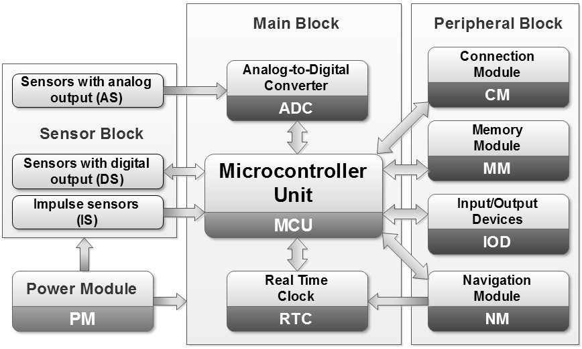

Figure 1 – Block flow diagram of supersensory computer

Now an experimental model of supersensory computer that measures the following parameters is developed and realized: temperature (-55…+125 °C), relative humidity (0...100 %), atmospheric pressure (300…1100 hPa), illuminance (0…70000 Lux), mechanical vibrations (-16…+16 g (3 axes)), acoustic noise (including ultrasonic noise, 20…150 dB), magnetic field (0...1000 Gauss), ionising radiation (0...100000 uR/h) and electromagnetic radiation (0…4000 uW/cm²). [1]

Conclusions

In the future it is planned to solve following problems:
- Research the combined effect of various parameters on the human body and the development of mathematical models.
- Development of mathematical models to predict changes in environmental parameters.
- Development of a series of low-cost, compact supersensory computers, equipped with the maximum number of sensors.
- Empowering of supersensory computer by adding gas and medical biosensors.

References

- Supersensory computers for measurement and analysis of biologically dangerous factors of environment / Theoretical and Applied Aspects of Cybernetics - 2012 / PROCEEDINGS OF The 2nd International Scientific Conference of Students and Young Scientists - Kyiv: “Bukrek” , Taras Shevchenko national university of Kiev - 2012, p. 186-191.
Citation:

Varzar Rostislav Leonidovich
Anoprienko Alexandr Yakovlevich
SUPERSENSORY COMPUTER: IDEA AND ARCHITECTURE
PROCEEDINGS OF The XIII INTERNATIONAL YOUNG SCIENTISTS’ CONFERENCE ON APPLIED PHYSICS, 12-15 JUNE 2013, Taras Shevchenko national university of Kiev - 2013, p. 230-231.

