The influence of EU enlargement on EURO
Kirnos I.A.
Associate Professor of the Department of
International Business Activity, DonNTU
Lukashenko T.M.
Student majoring in “International Economics”, DonNTU

Introduction. Today the problems of the EU hit the headlines of mass media and Internet resources. We observe as the European Parliament has recently been forced to extend the credit tranche in connection with the debt crisis in Greece, with Spain and Portugal to follow. The current economic situation is the concern of the EU politicians, economists and the public. The Euro currency instability is currently a buzz word in publications devoted to facing the challengers of the EU member states, old and newly excessed countries. “Angela Merkel said that there is no point in constant enlargement of the EU if such growth will not allow the union to function properly.” A lot of authors tried to predict and research the situation with the stabilization of EU, like Stéfanie Laulhé Shaelou with the book “The EU and Cyprus: Principles and Strategies of Full Integration”, also Jacek Więcławski researched the Eastern enlargement of the EU and its impact on internal and external relations, the analyses and forecasts available before enlargement, it presents the real consequences of the process[1-2],[3-6]. But still the question is remained to be open and it is known that there are expressed fears that the EU enlargement causes destabilization of Euro currency and this may even result in the EU disintegration. So my research makes an attempt to trace in what way the EU enlargement impacts the stability of the Euro currency.
The purpose and the objective. The first aim is going to analyze EU enlargement as a controversial phenomenon which causes contradictory expectations, which are summarized in the following.
So on one hand the Europhiles of enlargement argue that:
1. The extension of the zone of peace, stability and prosperity in Europe will enhance the security of all its peoples.
2. The addition of rapidly growing economies with more than 100 million people to the EU market will boost economic growth and create jobs in both old and new member states.
3. There will be a better quality of life for citizens throughout Europe as the new members adopt the EU policies for the environmental protection and the fight against crime, drugs and illegal immigration.
4. The arrival of new members will enrich the EU through increased cultural diversity, interchange of ideas, and better understanding of other peoples.
5. Enlargement will strengthen the Union’s role in the world affairs - in foreign and security policy, trade policy, and the other fields of global governance [3].
In their turn, the Eurosceptics maintain that:
1. The EU enlargement could lead to mass immigration, and increased organized crime.
2. Workers from poorer countries will take jobs from the EU nationals, and companies will relocate to countries with lower labor costs and worse social protection.
3. The richer member states cannot afford to pay huge subsidies to the poorer states.
4. The broader the EU gets, the more difficult it is to achieve deep integration.
5. This will impede the EU development and will make negotiation and agreement process within the Union more complicated.
6. The expansion of the Euro union will cause depreciation of the euro currency.
The later opinion of Eurosceptics made me think whether there exists the direct dependence of Euro currency stability and the EU enlargement .
Thus, the purpose of this research is to determine to what extent and in what way the EU enlargement can work as a destabilizing factor for the euro currency[4].
To answer this question it is necessary
- to look at the importance of euro stability for EU economies;
- to summarize the factors that influence the currency stability;
- to evaluate the quality of this influence using the multifactor model.
So, why is the exchange rate stability so important for the European Union? The exchange rate has a significant impact on creating of conditions of national stability currencies. Its fluctuation volatility influences the value of exports and on the inflation expectations of economic agents, on the capital inflows and outflows between the foreign exchange market and other sectors of the financial market.
The higher level of integration into the world economy, the more open the economy is, the more important for it to maintain the stability of the exchange rate in the anti-inflationary purposes [2].
To understand the nature of stability and instability of the euro currency I found it reasonable to make an analogy with physics Pic.1 that studies the phenomenon of stability.
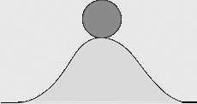
Fif.1. The System stability in physics
The System stability in physics is the property of a system in which any departure from an equilibrium state gives rise to forces or influences which tend to return the system to equilibrium. That is, a factor that is destabilized, feels and behaves like this ball on the top of a hill in the picture. But not all systems that are not stable are unstable.
Similarly, going back in the history, we witness the ups and downs of the euro currency, but somehow as the monetary system it came back to its equilibrium. The global economic crisis of 2008 serves as a striking example. There was a collapse in the stock markets that had a negative impact on the stability of the euro. But over time, and thanks to the International Monetary Fund funding the system restored itself and resumed its functionality [5].
Certainly, there is a significant number of factors, which influence the exchange rate, but I have chosen only five factors: Total Government Debt, GDP, Employment rate, Budget deficit and Inflation rate. The reason for this choice is dictated by the Maastricht Treaty convergence criteria of 1991.
In this research, we put forward the hypothesis that Eurocurrency is the self-repairing system. Therefore, probably, the deviation in the figures that reflect the factors chosen cannot prove that the system - the euro currency - is destabilized.
We will try to prove this hypothesis with the help of empirical research. As can be seen on the following table (1) I have used the time series tested on five factors from 1999 to 2011 as statistical tools. (For last 13 years). There was carried out the correlation-regression analysis and built the multifactor model.
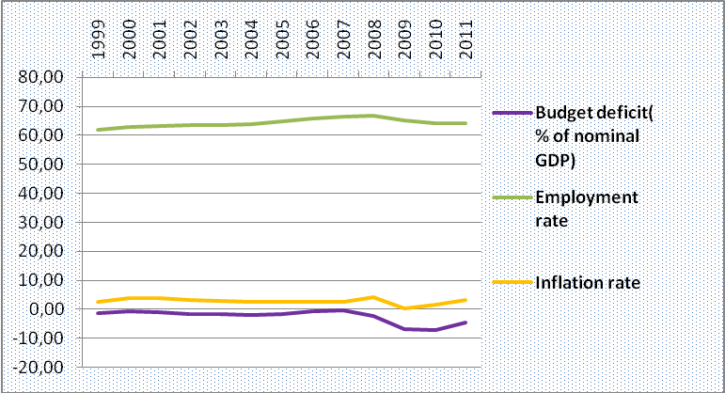
Fig 2. Macro indicators affecting the Euro currency
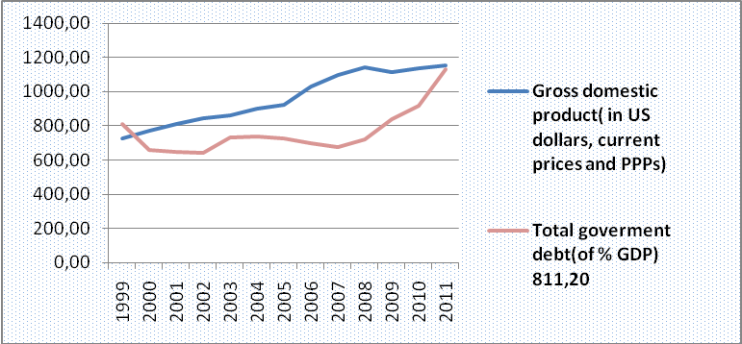
Fig 3. Macro indicators affecting the Euro currency

Fig 4. Euro exchange rate/ USD

We observed that some of the factors mentioned are not representative for our purposes as weak and strong EU economies show similar figures.
For instance, the average value of GDP by country groups is similar, as you can see on Fig. 5.
So it is impossible to prove with this factor that euro is influenced by the indicators of newly accessed states due to the EU enlargement.
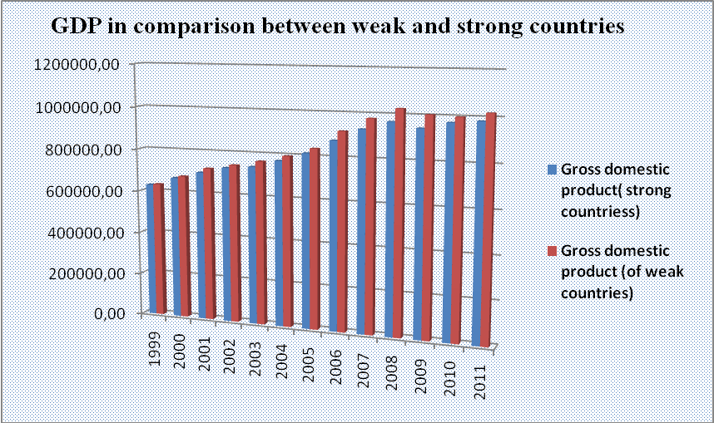
Fig. 5. GDP comparison between weak and strong countries

On the other hand, such indicators as Employment rate show obvious differences concerning weak and strong countries, which determined their selection for building a multifactor model.
Such differences in indicators give me an opportunity to suppose that weak newly exceed states can be the source of destabilization of the common currency.
Between the two indicators of Employment rate to Euro and Gross Domestic Product (Table (3)) to Euro there is a direct correlation: the growth factor causes growth rate. (Significant factors, the values ​​of which, more than 0.5. These are - "Employment and GDP" on the Figure 6.
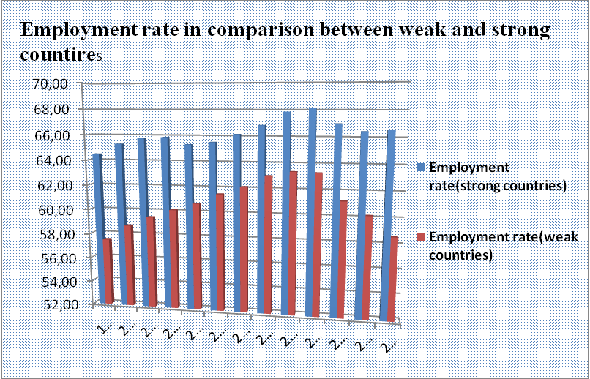
Fig. 6. Employment rate comparison between weak and strong countries
All above mentioned summarizes the multifactor model (see Table 1).

Table 1 Regression statistics of multifactor model
Multiple R | 0,862514014
R-squared | 0,743930424
Normalized R-squared | 0,692716509

Multiple R - is a statistical tool used to derive the value of a criterion from several other independent, or predictor, variables. It is the simultaneous combination of multiple factors to assess how and to what extent they affect a certain outcome [12].
R-Squared is a statistical term saying how good one term is at predicting another [12].

Table 2 The coefficients of the equation obtained from the regression
Y-intersection | 2,525451967
Employment rate | -0,015168338
Gross domestic product (in US dollars, current prices and PPPs) | -0,000722412

The exchange rate of euro was taken against the dollar. The higher rate of the euro - the lower value of Euro/USD, and therefore there is an inverse dependence (correlation coefficient of GDP to Euro and Employment rate to Euro with a negative sign) [7].
Conclusion. As a result, we can observe that a change of one of the factors on the unit results in changing the exchange rate of currency on the value of its coefficient.
With the help of correlation analysis it is possible to evaluate the quality of the influence of these factors on the euro currency and can get the regression statistics model. Analyzing the multi-factor model, we can say that if a similar situation in the strong countries is not so critical for the whole European Union, the effect cannot destabilize the euro currency completely, while for the new member countries (initially economically-weak) it is a period of adaptation is needed. (The factors which influence on the Euro have passed the criteria by Fisher and Student).
Thus, the factors taken into account in the model, demonstrate the negative impact that leads to the destabilization of the currency. However, this does not lead to the destabilization of the overall system - Euro currency because, not all systems that are not stable are unstable. Destabilization of any factors - this is a normal phenomenon, if the system is willing and able to recover. I believe that the EU enlargement may cause only a temporary destabilization of the euro currency in the period of adaptation of new members – countries. As history of the European currency shows despite various factors of disability the system is capable of recovery. So pessimism by Eurosceptics does not prove to be well grounded.
References
- Ross C. (2002): Perspectives on the Enlargement of the European Union, Brill, pp. 160 – 168.
- Ott Andrea, Inglis Kirstyn (2002) :Handbook on European Enlargement: A Commentary on the Enlargement, Volume 1: A Commentary on the Enlargement Process, pp. 505-510
- McLaney E.J. (2006): Business Finance: Theory and practice, Moscow: Prentice Hall Financial Times (An imprint of Pearson Education).
- Cheng F. Lee; John C; Alice C. (2009): Financial analysis, planning and forecasting, 2d ed., Singapore: WorldScientific.
- Hillion Christophe (2004): EU enlargement, pp.144 – 149
- European Union enlargement: a historic opportunity European Commission. Directorate General for Enlargement. Information and Interinstitutional Relations Unit ( 2000): pp. 20 - 25
- Victoria Curzon Price (1999): The Enlargement of the European Union, pp. 170- 174
- Cremona Marise ( 2003): Collected courses of the Academy of European law: The enlargement of the European Union, Academy of European Law, European University Institute, pp.202-208
- Kireev A.P. (2001): International Economics,pp.50 - 55
- Exchange rates Euro to Dollar http://www.ecb.int/stats/exchange/eurofxref/html/eurofxref-graph-usd.en.html

Stéfanie Laulhé Shaelou ( 2009 ): The EU and Cyprus: Principles and Strategies of Full Integration, pp. 310 – 315

Informational dictionary http://www.techopedia.com/definition/27369/multiple-regression

