Political factor's Impact on the Ukrainian Stock Market Dynamics
Malyshko A.V.
Associate Professor of the Department of
International Business Activity, DonNTU
Tykhomyrova O.S.
Student majoring in
«International economics», DonNTU

The stock market plays a pivotal role in the growth of the industry and commerce of the country that eventually affects the economy of the country to a great extent. It is reason that the government, industry and even the central banks of the country keep a close watch on the happenings of the stock market. The stock market is important from both the industry’s point of view as well as the investor’s point of view.
Stock market development depends on a group of macro- and micro- environmental factors. Micro-environmental factors are issuers, investors, financial intermediaries. Macro-environmental factors comprise economic, demographic, legal, political, and social conditions, technological changes, and natural forces [1].
Schwert (1989) examined how strongly the volatility of macroeconomic variables was correlated with stock market volatility. He found that the most of variability cannot be explained, but that a number of variables exhibit some correlations.
The process of market transformations in Ukraine has created the preconditions for the formation of the securities market, which led to a commitment in the study of this problem among native scientists. This is reflected in the works of Y. Petruni, V. Oskol, G. Kalac, V. Sheludko and others [2]. A number of economists such as W. Sharp, F. Black, M. Showls, Petruni, В.А. Evtushevskiy, А. Mozgovoi claim that political factor is one of the most significant macro-environmental factors that affect the stock market dynamics [3].
Therefore, the main purpose of this paper is to determine interdependence of political events in Ukraine and stock market state through making a comparison of the chronological order of political events with dynamics of the stock market development main indicators.
Chronological analysis has been as follows. Periodization of the stock market changes has been provided; the time period from 2000 to 2009 was investigated. In our case the key indicators of the stock market prosperity are:
- PFTS index;
- FDI Rate of growth.
We chose these variables, because they represent accepted measures of the Ukrainian stock market performance.
The main idea of this paper, then, is to provide a clearer mapping of political circumstances and the stock market volatility interrelationships.
Alesina et al show that countries with lesser government stability have lower levels of economic growth [4]. Barro records similar evidence: revolutions and political assassinations have negative impact on investment [5].
Political factor has a significant influence upon financial and economic indicators such as: state of economy, prices and rate of inflation, interest rates, unemployment, welfare, exchange rates, stock market, and foreign direct investment [6]. A number of theoretical and empirical articles argue that political instability hinders stock market growth [7]. Specifically, it has been suggested that political instability increases policy uncertainty, which has negative effects on productive decisions. A high probability of a change of government implies uncertain future policies, so that risk-averse economic agents may avoid taking important economic decisions or might exit the economy, preferring to invest abroad [8].
Different political events have different influences for the stock market changes and foreign investors’ behavior. In this paper political events are divided according to their after-effect character:
- Events with a positive effect.
- Events with a neutral effect.
- Events with a negative effect.
Political events which took place during the observed period and could have positive, neutral or negative impact on the performance of stock returns in Ukraine are presented in Table 1.
Table 1
The main political events which could have impact on the dynamics of stock returns in Ukraine (April 2000 - May 2009) [9,10]
№ | Date | Political events | Impact
1. | 16 April 2000 | Referendum on additional authorities of the President of Ukraine | Positive
2. | 16 Sept 2000 | Disappearance of journalist H. Gongadze | Negative
3. | 28 Nov 2000 | The beginning of the cassette scandal | Negative
4. | 26 April 2001 | Resignation of Victor Yushchenko and the government | Negative
5. | 31March2002 | Parliamentary elections | Positive
6. | 28 May 2002 | V. Litvin was elected the Head of the Verkhovna Rada (Rada) | Positive
7. | 16 Nov 2002 | Resignation A. Kinakh and the government | Neutral
8. | 12 June 2003 | Kuchma’s speech about the necessity of changes in the Constitution of Ukraine | Positive
9. | 19 Sept 2003 | Agreement on creation of the Common Economic Area (CEA) was signed | Positive
10. | Oct-Dec2003 | Tuzla crisis | Negative
11. | 1 Jan 2004 | Mortgage Law came into a force | Positive
12. | 17 April 2004 | Rada passed the draft of the Agreement on creation of CEA | Positive
13. | Oct-Dec 2004 | Presidential elections and the “Orange” revolution | Positive
14. | 20 Jan 2005 | Inauguration of Victor Yushchenko | Neutral
15. | 21 Dec 2005 | EU determined to assign status of country with market economy to Ukraine | Positive
16. | 1 Jan 2006 | Reform which limit the power of President and strengthen Prime-Minister | Neutral
17. | 26 March 2006 | Parliament elections. V. Yanuckovich was elected the Prime-Minister. | Positive
18. | 6 July 2006 | A. Moroz was elected speaker of Rada | Neutral
19. | December 2006 | The Law required to enter WTO was passed | Positive
20. | Apr–June 2007 | A political stability in Ukraine | Positive
21. | 30 Sept 2007 | Unscheduled Ukrainian parliamentary election | Negative
22. | 5 Febr 2008 | WTO accession | Positive
23. | 8-12August 2008 | Armed conflict between Russia and Georgia | Negative
24. | 8 October 2008 | The Ukrainian parliament was dissolved by president Yushchenko | Negative
25. | May 2009 | Diplomatic conflict between Ukraine and Rumania | Neutral
26. | August 2009 | “Gas war” with Russia | Negative

These data were chosen on my own from periodicals considering the importance and attention that were given by mass-media.
The stock market index (First Ukrainian Securities Trading System (PFTS) index) reacts to any changes immediately. “The PFTS trading platform transacts the lion’s share of agreements for securities in Ukraine. PFTS index is the only acknowledged “thermometer” which precisely shows the political and economic “temperature” of the Ukrainian securities market” [11]. PFTS accounts for about 90% of foreign trade [12].
Positive political events have more significant impact on behavior of stock returns. Market reaction to the mainly positive events may be indicative of the fact that economic agents are more likely to revise their estimates of future returns upward than downward, or that positive news are more informative than negative news. From another point of view, the fact that only positive values of news have significant effects on stock returns reveals information about market efficiency [13]. In order to indicate relationship between stock market dynamics and political events in Ukraine (list of them is introduced earlier) stock market dynamics graph is presented on Figure 1. We use the indexes of PFTS to illustrate Ukrainian stock market development. Using the Figure 1 it will be possible to see how stock market indexes react to different political events in the state.
According to the Figure 1 it can be seen that parliamentary and presidential elections have positive impact on stock market dynamics whereas conflicts and scandals lead to changing the situation for the worse.
The change of government which is in the constitutional framework, contribute to the economic growth, while forced regime change has a significant destimulating effect [14].
To investigate Ukrainian stock market dynamics comprehensively the corresponding periodization should be provided. Breakpoints of stock market indexes underlie fragmentation. Namely, beginning of 2004 year which can be characterized as rapid increasing and beginning of 2008 when sharp decreasing may be observed.
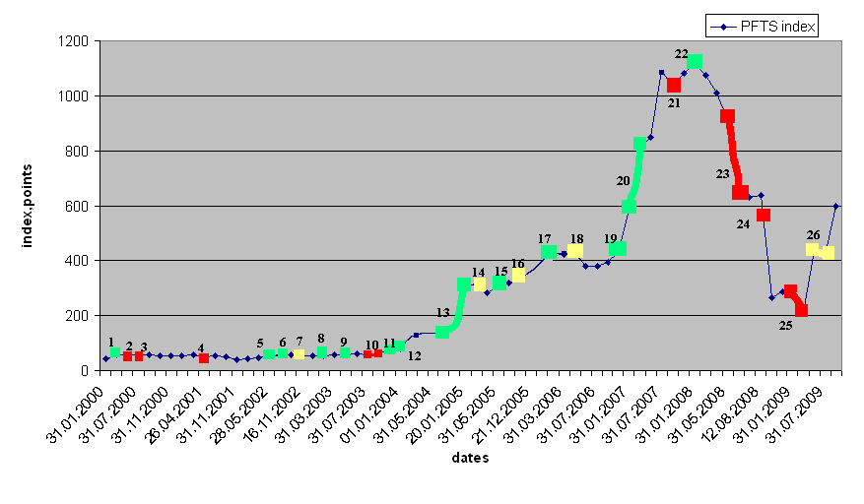
--political events with negative impact --political events with neutral impact
--political events with positive impact
Fig.1. Performance of PFTS index in 2000-2009

Thus, 3 periods of stock market performance can be studied: 1. 2000-2003; 2. 2004-2007; 3. 2008-2009.
Additionally, the use of time series data allows us to test the influence of political events on the FDI inflow growth.
The first part of the period investigated. 2000-2003 is the period of Ukrainian stock market formation. The relevant dynamics can be characterized by insignificant changes. Despite government replacement and “cassette scandal”, enactment «About extra miles concerning Ukrainian stock market development” and signing the Agreement on creation of the Common Economic Area helped to regulate stock market movements. Figure 2 demonstrates PFTS index and FDI dynamics. According to this figure after parliamentary elections in 2002 investors became more active and it could be explained by stabilization of political situation in Ukraine and introduction of new laws and stock market peculiarities [15].
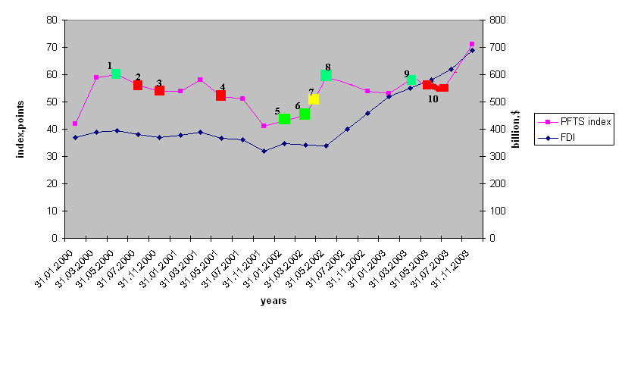
--political events with negative impact --political events with neutral impact
--political events with positive impact
Fig. 2. Performance of PFTS index and FDI inflow over a time period
from 2000 until 2003 [16]

Ukrainian stock market since the beginning of its existence (1993) and by the end of 2000's had a miserable size. Trading volumes and overalls reached neither that of the European markets, nor the Russian ones. Development of the stock market stalled primarily because of the lack of legislative framework and weak technical support.
The second part of the period investigated. The first major foreign investors have come to the Ukrainian market since the Orange Revolution. A second surge of interest in the West to the Ukrainian public companies has fallen to 2007 - during the economic boom preceding the crisis. By the time the leading exchanges in Ukraine was PFTS [16].
In the past three years the Ukrainian equity market has grown from one of the smallest in the region, FDI growth from 2004 until 2007 was 343%. This dramatic growth in Ukraine’s market capitalization when compared to Hungary, Poland and Czech Republic is explained by the positive effect of the Orange Revolution. Serious engine for the stock market was also the end of the election race and the stabilization of political situation in Ukraine. After new president coming to power rating agencies have improved forecasts for the country since the uncertainty has disappeared. "This has led foreign investors to pay attention to domestic securities”, a trader Oleg Samokhin said. In addition, residents took up the largest investment companies in the country, actively promoting its market.
An enormous growth of FDI and PFTS index was depicted on the Figure 3. It is related to several political reforms and presidential elections. Even the appearance of political stability led to the growth of Ukrainian stock market indices quickly. The price of domestic securities was actively growing, sometimes even against the negative performance of world stock exchanges.
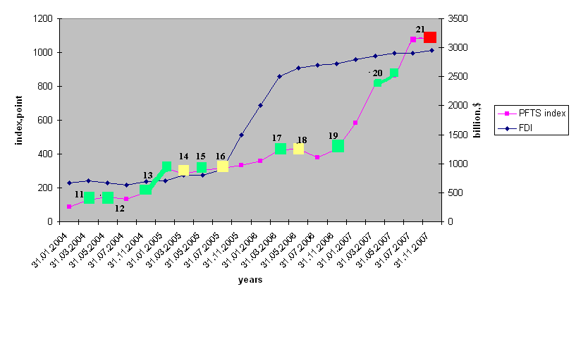
--political events with negative impact -- political events with neutral impact
--political events with positive impact

Fig. 3. Performance of PFTS index and FDI inflow over a time period
from 2004 until 2007

Assignment market economy status to Ukraine by European Union influenced stock market index and as a result had a profound effect upon investors’ behavior. In Ukraine, the growth of securities has traditionally been accompanied by any change of power. Hopes of investors on the positive developments in the economy and the real activity of financial services groups in the redistribution of financial and industrial resources played role in this process.
The third part of the period investigated. If in 2007 the yield of the Ukrainian stock market has been one of the best in the world, in 2008, on the contrary, the downfall of PFTS stock index has become one of the biggest.
First, the PFTS index lost 76% of its value it returned by the end of 2004 - early 2005's, and the capitalization of Ukrainian stock market has declined in virtually quadruple - from $ 110 billion to $ 22.5 billion. Ukraine was included in the list of countries with the most adverse current economic situation such as Hungary, Baltic States, etc. The dynamics of stock market in 2008-2009 is shown on the Figure 4.

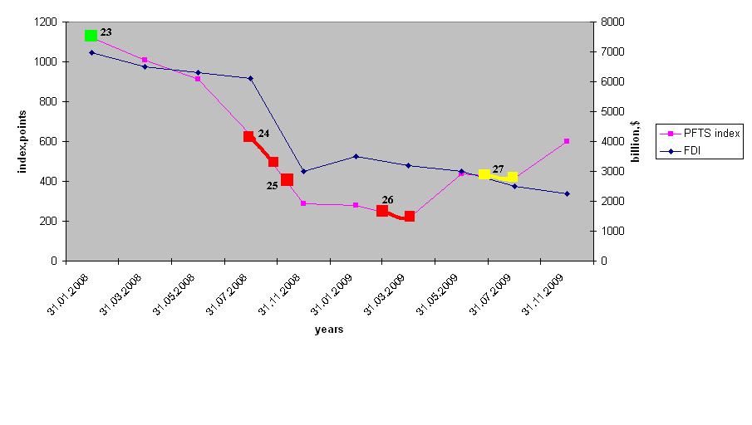
--political events with negative impact --political events with neutral impact
--political events with positive impact
Fig. 4. Performance of PFTS index and FDI inflow over a time period
from 2008 until 2009

In addition, the growing political tensions related to the upcoming presidential elections in late 2009 and the lack of consolidated position of all branches of government, most likely was not allow the Ukrainian government to take effective decisions to stabilize the economic situation in the country.
Preparation for the presidential election-2009 was a key event of the year, which was given special attention by the Ukrainian politicians. In this regard, the adoption of important reforms needed to address a number of economic problems in the country was delayed and was implemented through the prism of their own political ambitions that will only exacerbate the confrontation between the ruling political elite and will not bring positive results for the stock market growth [17].
It was proved that the influence of the political factor is the most important explanatory variable. This is in line with our prediction that political instability is harmful for stock market development.
This paper looked at the links between stock market dynamics and political events in the Ukraine in detail. Our time series’ case study of explores the main indicators of Ukraine’s stock market development. Moreover, we investigated the links between stock market volatility, political events and FDI inflows.
Political situation in the state stipulates improving of situation on the stock market and the attraction of investors, so political events with negative impact (unscheduled parliamentary elections, conflicts, government resignations etc.) lead to stock market index drop, and, as a result, FDI inflow reduction.
References
- ShareTipsInfo “Importance of stock market”, available at: http://www.sharetipsinfo.com/economy-stock-market.html last viewed 28.09.10. 2.Тертышный С.А. Рынок ценных бумаг и методы его анализа - СПб.: Питер, 2004. – 20 c. 3. Fontanills G., Gentile T. (2001) “The Index Trading Course” – Wiley – 17 p. 4. Alesina, A., Ozler, S., Roubini, N., Swagel, P. (1996). Political Instability and Economic Growth // Journal of Economic Growth, Vol. 1 (June), pp. 189-211. 5. Barro, R. J. (1991) Economic Growth in a Cross-Section of Countries // Quarterly Journal of Economics (May), pp. 407-443. 6. Азаренкова Г. Состояние фондового рынка в Украине // Экономика Украины. – 2005. - № 2. – C. 27-32. 7. Оскольський В.В. Ринок цінних паперів України: погляд через призму діяльності Української фондової біржі, 2001. — К. : УФБ,. — 216с. 8. Cukierman, A., Edwards, S., Tabellini G. (1992) Seignorage and Political Instability, American Economic Review (June), pp. 537-555.9. Chronology of events in Ukraine, available at: http://www.vru.gov.ua/index.php?r,mapr,sitesmapr, last viewed 20.09.10. 10. Chronology of Ukrainian independence, available at: http://news.liga.net/info/NS080028.html, last viewed 25.09.10. 11. Barro, R.J.(1996) Democracy and Growth, Journal of Economic Growth, Vol. 1, No. 1 (March), pp. 1-27.12. Мироненко В. Реформа фондового рынка Украины // Инвестицуионная газета. – 2007. - №49. - С.60. available at: http://berg.com.ua/press/stock-market-reform-ukraine/ last viewed 10.10.10. 13. Fabozzi, F.J. (2004).Fixed Income Analysis – 2nd Ed. – Frank J. Fabozzi Associates, pp.325-338. 14. Тараканов Г.И.Особенности влияния политических и географических факторов на экономический рост, available at: http://www.m-economy.ru/art.php3?artid=22990 last viewed 28.09.10 15. ИнвесторUA Основное влияние на рынок окажет подготовка к выборам в местные органы власти – эксперты, available at: http://www.investor.ua/analytics/browse-3930.html last viewed 10.10.10. 16. State Statistics Committee of Ukraine. “Foreign direct investments. Monthly activities” available at: http://ukrstat.gov.ua/ last viewed 10.10.10. 17. Захаров Р. Экономика Украины и фондовый рынок все меньше зависят от политических событий. Информационное агентство “CBonds”(2007), available at: http://www.cbonds.info/all/rus/news/index.phtml/params/id/386087 last viewed 28.09.10. 18. ВУК://Рынок и Аналитика/Рынок ценных бумаг/Обзор (2010) доступно на: http://vuk.com.ua/market/securities/2009.05.22 last viewed 30.09.10.

